NAME: - Stephen Yohanna

CANDIDATE NUMBER: - 3130

CENTRE NAME: - Heart of Yorkshire Education Group

CENTRE NUMBER: - 48330

PROJECT TITLE: - Qubita: a simulation for assisted quantum computing learning

QUALIFICATION CODE: - 7517A

Date: - 07/05/2025

CONTENTS
Analysis ............................................................................................................. 5
Introduction............................................................................................ 5
Investigation........................................................................................... 5
End User..................................................................................... 5
Current System.......................................................................... 8
System Limitations................................................................................ 14
Initial Model........................................................................................... 15
Initial Software Objectives.................................................................... 18
Feedback Plan....................................................................................... 19
Design................................................................................................................ 20
Hierachy Diagram.................................................................................. 20
Qubita Module....................................................................................... 21
Bloch Sphere Module............................................................................ 21
State Vector Module................................................................. 22
User Interface Initial Design.................................................................. 23
Putting It All Together............................................................................ 24
Transform State Module....................................................................... 26
Superposition Module........................................................................... 28
Measure Module.................................................................................... 29
User Interface........................................................................................ 32
Potential Errors from User Input........................................................... 38
Post-Interview 2 Design........................................................................ 38
Questions.................................................................................. 38
Key Takeaways.......................................................................... 39
Gates Module............................................................................ 39
Updated UI................................................................................. 41
Input-Process-Output Table..................................................... 42
Technical Solution............................................................................................. 43
Hierarchy Diagram................................................................................. 43
Measure................................................................................................. 44
Gates...................................................................................................... 45
StateTransform...................................................................................... 48
SuperPosition......................................................................................... 49
BlochSphere........................................................................................... 51
StateVector............................................................................................ 53
Qubita.................................................................................................... 58
Qubita Class.............................................................................. 59
Main()......................................................................................... 63
Run and Validation Functions....................................... 69
RunTransform................................................... 69
RunMeasure...................................................... 69
RunSuperposition............................................. 70
Gates Run......................................................... 71
ValidateTheta................................................... 72
ValidatePhi...................................................... 72
General Reflections............................................................................. 73
Testing.............................................................................................................. 74
Updated Objectives............................................................................. 74
Black Box Test..................................................................................... 76
Test Table................................................................................ 76
Test Evidence.......................................................................... 80
Module Test........................................................................................ 104
Evaluation....................................................................................................... 110
Tabular Objectives Evaluation............................................................ 110
Feedback (Google Forms) ................................................................. 112
Mr. W. C Feedback................................................................. 115
Specialist Feedback............................................................... 116
UI Reflections..................................................................................... 118
Areas of Improvement........................................................................ 119
The Simulation........................................................................ 119
The UI...................................................................................... 120
Feedback................................................................................ 120
References...................................................................................................... 121
Appendix......................................................................................................... 124
Qubita v1.0 Documentation............................................................... 124
ANALYSIS
INTRODUCTION
Quantum computing is a developing field of computer science where the classical way of representing information with two states is replaced with a different representation system. In this new system, information can be represented in either of the two classical states (formally known as the basis state in quantum computing) or a combination of both s. This combined state is known as a superposition and a value is associated with each basis state. The medium that stores information in this way is called a qubit and Computer Scientists physically implement this with any particle that exhibits quantum behavior for example atoms (Wong, 2022). Classical Bit states can be transformed with Logic Gates utilizing Boolean Algebra functions. In the same way, Quantum Bits can be transformed with Quantum Gates that utilize Linear Algebra functions usually represented with Matrices (IBM, n.d.).
Quantum behavior and how it is used to extend computing and information representation capabilities is often hard to explain to beginner computer scientists such as A-Level students due to its abstract nature.
For my project, I am creating an interactive simulation based on an abstract model of a qubit that limits it to its behavior of existing in a superposition of states and collapsing to one state when measured. Although I will not be modelling Quantum Gates and how they affect the Qubits, I will allow the user to input matrices via a prompt or measure the state of the qubit with a command. Based on the user input, the qubit can respond either by geometrically transforming states on the simulation plane or collapsing to one state.

INVESTIGATION
End User
The intended end users for this solution are A level Computer Science and Maths students. For this reason, I anticipate that the end user will have a substantial amount of technical knowledge therefore, I plan on making the UI not too abstract; just one that is sufficient to parse commands to the qubit, perhaps a command line. This can be re-evaluated during the design stage. To further investigate the problem potential user needs, I interviewed Mr. W. C an A-Level Maths and Computer Science student asking the following questions:

QUESTION SET 1 – SIMULATION APPROACH
- Have you ever used simulation assisted learning?

- If yes, Was it interactive or not?

  - If yes, what did you like about the interactive interface?

  - If no, do you think an interactive model will be beneficial in learning hard concepts like fundamentals of quantum computing?

QUESTION SET 2 – USER INTERFACE
- On a scale of 1 to 10, where do you think your level of IT expertise falls under? Would you say you’ve used a wide range of different applications with different Interfaces?

- Would you say most of your peers in Computer Science A level have the same technical expertise as you?

I intend to simulate a qubit on a 3d graph. As a user, you can interact with this system using a command prompt which the qubit listens and responds to:

- Are there any comments on this approach?

- How can it be improved?

Here are some benefits of a command line:
    - Gives you more control over the interface.
    - A lot of tools you’ll come across as a computer scientist are command line based, using more applications with this layout gives you good experience with it.
Benefits of Graphical interface:
    - Easy to use.
    - Visually appealing.

- Based on the Information above, how would you like to interact with the simulation?

I refrained from asking questions about quantum computing as I do not expect the user to have any knowledge on the topic, rather, I have designed the questions to evaluate the potential user’s level of technical expertise and experience with simulation assisted learning. The Interview Yielded the following answers:
Date of Interview – 16/10/24
Mode of Interview – Online Teams meeting

QUESTION SET 1:
- I have used simulation assisted learning to help me with my A-levels; for example, I have used PhET simulations to help improve my understanding of certain scientific principles.
- Yes - My favourite aspect of interactive interfaces found in such simulations is the ability to communicate clearly between the system and user. An intuitive interface is very important when it comes to simulations.

QUESTION SET 2
- I’d say my level of IT expertise is around a 7. I have experience with a wide range of different applications with different interfaces, but I tend to stick to a select few applications that I need for my studies.
- Yes, most of my peers have a similar level of technical expertise.
- I believe the approach to UI is intuitive and simple for users to grasp.
- It can be improved by adding more features to the interface rather than just a generic graph plane.
- I am personally fine with a command line interface and believe that users with a similar level of expertise will think the same.

Summary of User Needs
Mr. W. C, an A-Level Maths and Computer Science student at Wakefield College, has experience with interactive Simulation Assisted Learning. From his experience, he enjoyed simulations that have a clear and direct interface between the system and the user. He has a used a wide range of IT solutions and applications and believes that his peers taking A-Level Computer Science would be at the same level of technical expertise as him. He believes that using a graph plane is intuitive enough for users like himself, however, he suggests that more elements be added to the interface.

CURRENT SYSTEM
At the moment, there is no system to teach quantum computing concepts to A-Level students as it is not part of the curriculum. I believe that my solution creates an intuitive tool that helps students understand fundamental Qubit behaviours allowing quantum computing to be introduced to the syllabus. I did find a system online that models Qubits to explain some of their behaviours:
The Qubit Game (Google, n.d.)
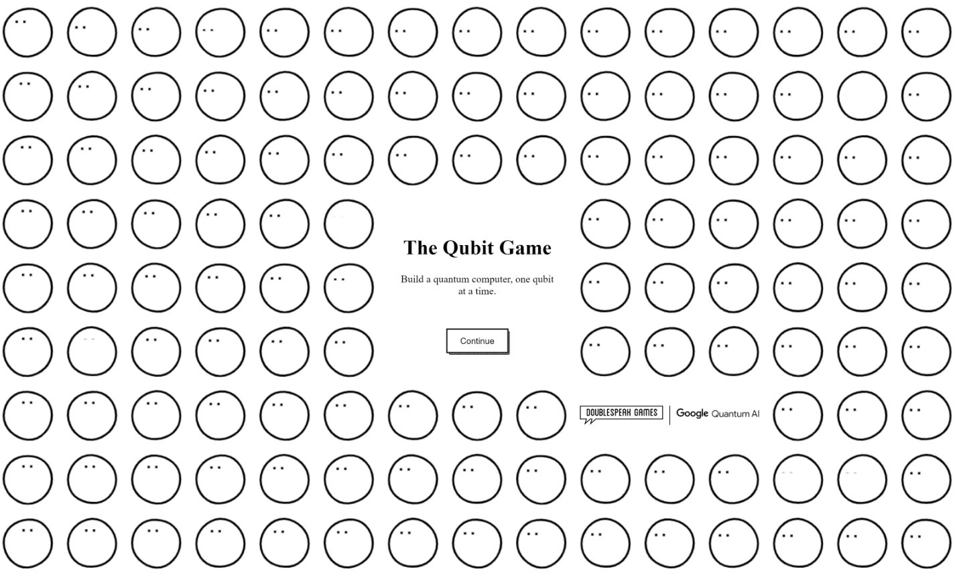
This is an educational 2D game developed by google with HTML, CSS and JavaScript. The game starts with a single qubit; but the number of qubits can increase as the player builds more during the course of the game.

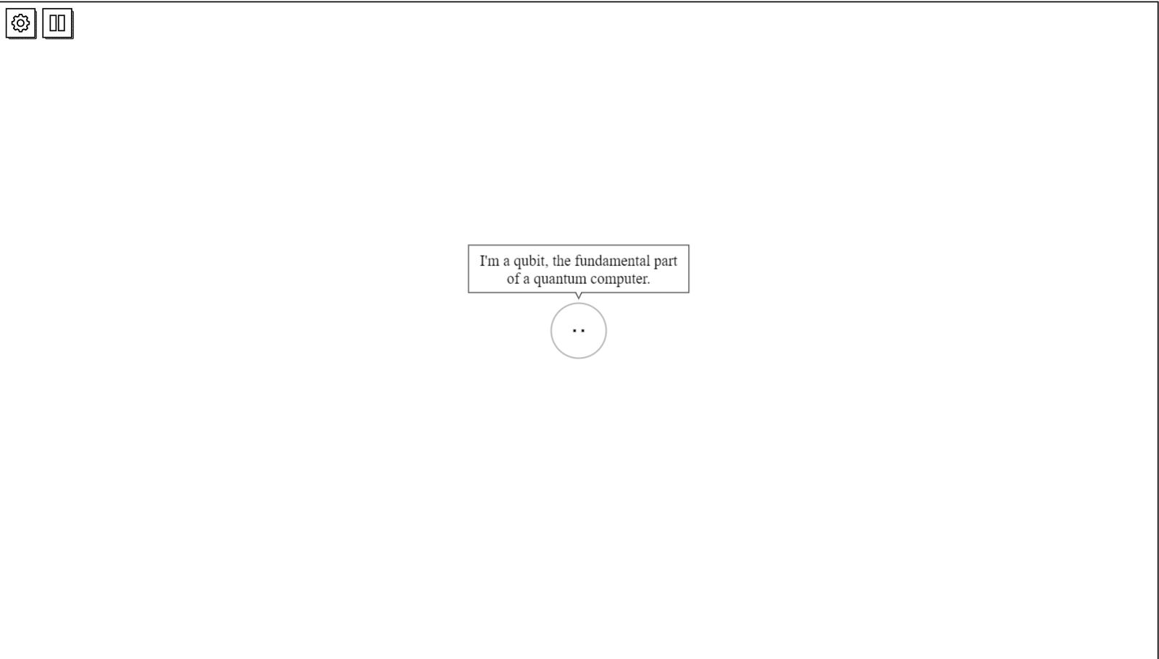
Each qubit tries to compute by coherence implying that a quantum bit must be in coherence to be able to work properly. While the computation is taking place, the game requires the user to protect the qubit from heat particles by clicking on them. This was done to demonstrate the concept of decoherence, where physical factors cause a qubit to lose information it was previously computing.
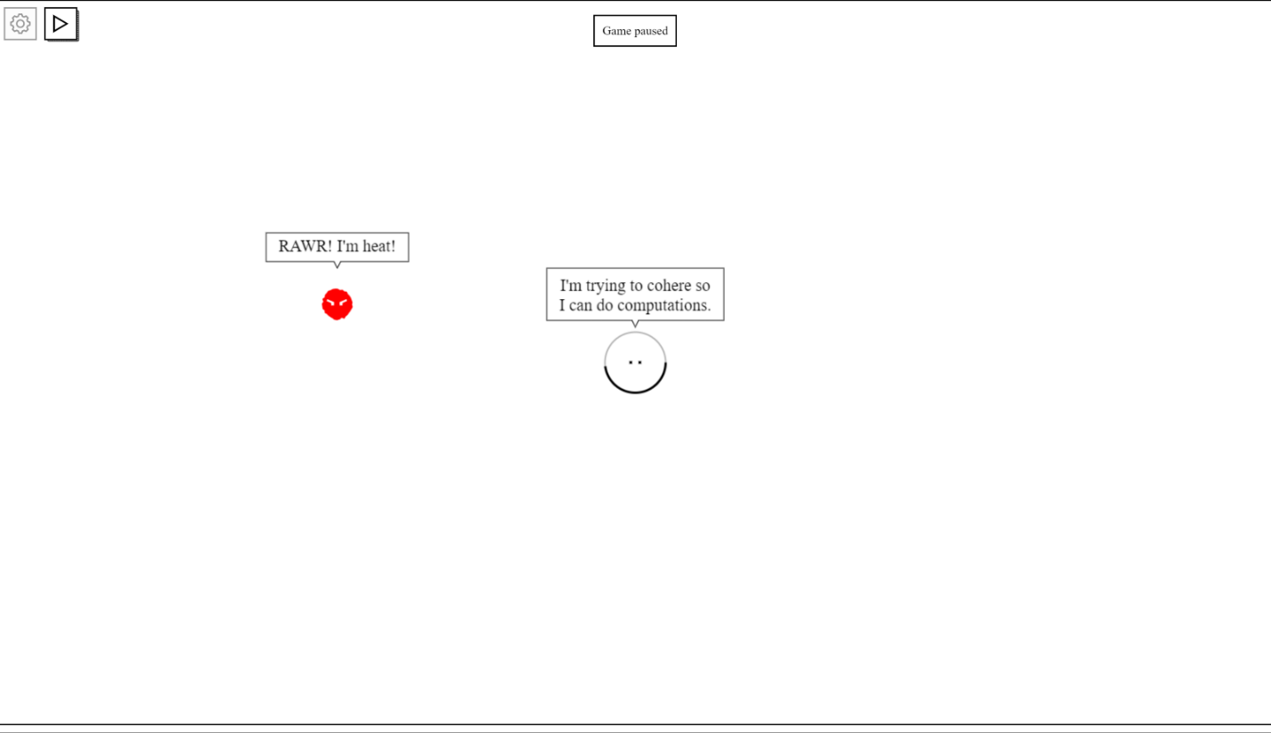After the qubit has finished computing, the user can measure the information which ranges from 1 to 10. The more information measured; the more information points the user scores. The user can trade points to complete objectives such as building more qubits, improved qubit speed, better cooling systems, etc. See the image below:
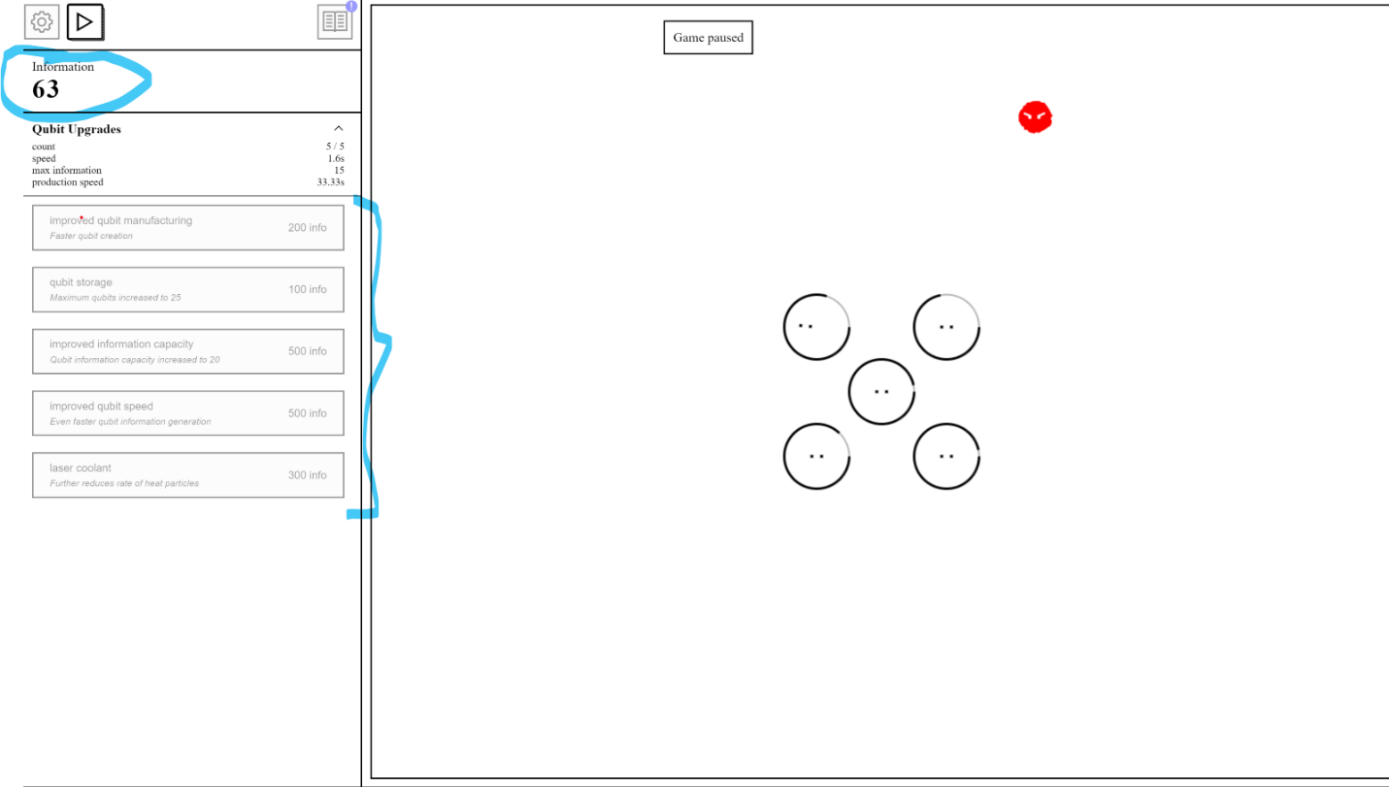
The qubits can also entangle; a phenomenon where qubits are in sync that is, the state of one qubit affects the other entangled qubits. This makes computing faster demonstrating that qubit entanglement is an advantage in quantum computing. In the image below bits connected by lines are entangled.
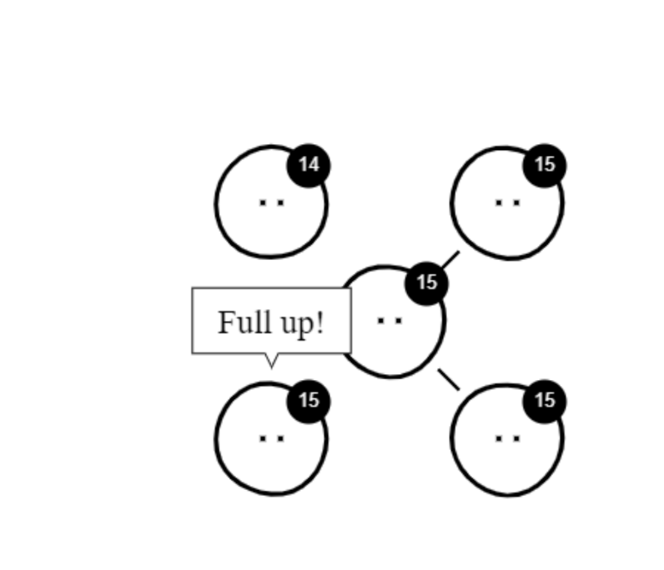
The game continues giving objectives and more qubits are made until they are enough to build a fully functional quantum computer. This marks the end of the game.
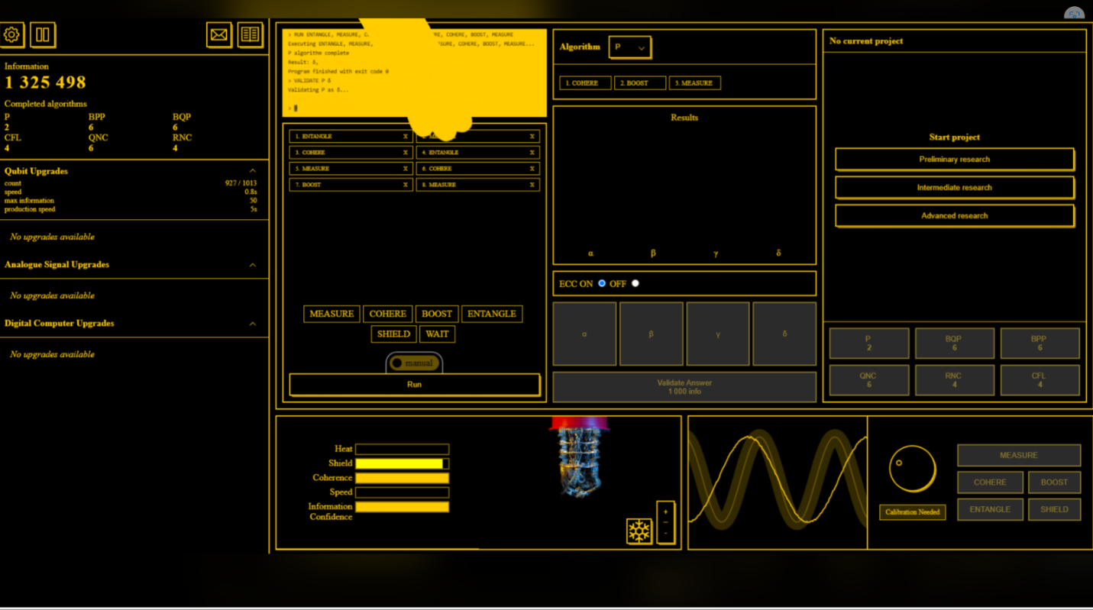
Problems with the current system
- While this system may work for less advanced students like high school students, the concepts are modelled too abstractly to be of substantial benefit to A-Level students.
- It is a 2D system which does not properly model a qubit. A qubit is usually modelled as a sphere in a 3D plane.
- It does not demonstrate the fundamental behaviors of a qubit which I intend to include in my system.

My system is an improvement because the qubit will be simulated on a 3d plane allowing the user to see all dimensions of the qubit. I also allow the user to directly enter commands that the qubit responds to making them feel like they are performing the computation themselves. It also models the key aspects of quantum computing that will be useful to understanding quantum information representation.

LIMITATIONS OF MY SOLUTION
SOFTWARE OR HARDWARE | SPECIFIC AREA | DESCRIPTION
Software | Running and Accessibility | I am using the interpretative language python and so the user must have it installed on their computer. This limits the accessibility of the application however I have a very niche target user and expect them to
Software | 3rd Party Libraries | I am going to be utilizing matplotlib and other libraries for various purposes hence the user must have these libraries installed.
Software | User Interface | Some people may find using a command line to interact with the model intimidating. I will make sure to include well-documented instructions on how to use the system and commands you can use.
Hardware | Computing Power | I don’t expect the program to use more computing power than the average modern computer can handle. The User might experience problems if they use an old computer.
Software | Simulation | The initial version of my system will be a single quantum bit system. In the future I intend to allow representations of multiple qubit states to make the system more functional.

INITIAL MODEL
A Qubit is modelled with a Bloch Sphere. Although a block sphere has many more attributes, we can abstractly model a Qubit with a Sphere in a 3D plane with dimensions x, y, z and model its current state as any point on the sphere. This leaves us with the following attributes:
- Center – An array with 3 elements each corresponding to the x, y, z coordinate of the center.
- Radius – An integer or float number that defines the Radius of the sphere.
- State – An array with 3 elements each corresponding to
We may also consider the following methods:
- An instance method that initializes the qubit object in the basis states (1 or 0)
- A method that initializes a superposition state on command.
- A method that measures the state of the qubit on command which makes it collapse to state 1 or 0.
- A method that transforms the state based on the user’s matrix input.
A class diagram is used to model this below:
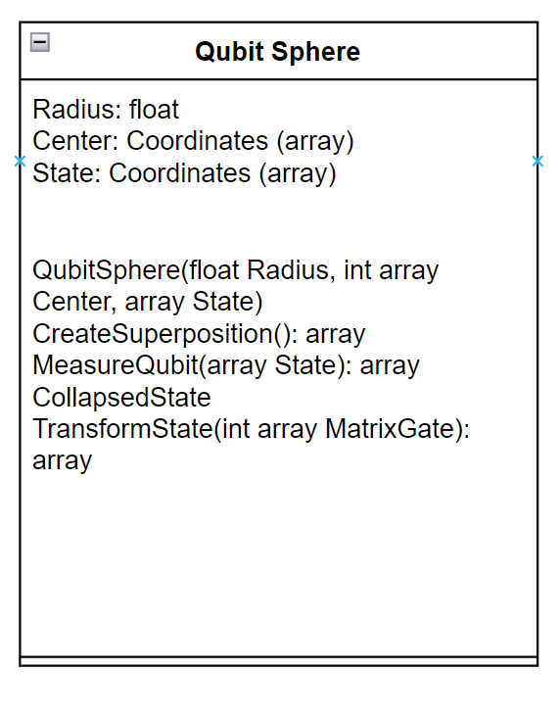
State 1 and 0 can be modelled as the poles of the Sphere; North Pole – 1 (point x=0, y=0, z=1), South Pole – 0 (point x=0, y=0, z=-1). If we initialize a qubit sphere object with radius 1 and coordinate of the center x=0, y=0, z=0 using the abstract class and set the initial state to 1, the object diagram will look like the one below:
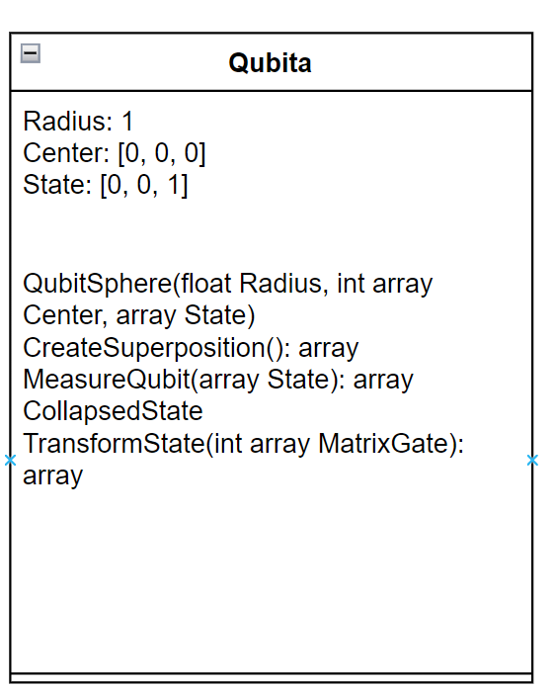
We can use an arrow pointing to the coordinate of the current state of the qubit on the sphere, to keep display the current state of the qubit visually. With the object above, it will initially look like the diagram below, but the direction of the arrow can change as commands are executed by the user.
INITIAL SOFTWARE OBJECTIVES
- Initialize Quantum Bit
  - Create a Bloch sphere object and graph it on the 3d plane.
  - Initialize the basis state to be 1 or 0 (vector arrow north or south)
  - Start listening for commands.
- Command to initialize superposition state is executed.
  - Define a point on the sphere that is not equivalent to 1 or 0 (not at the north or south pole)
  - Vector arrow starts facing that point.
  - Continue listening for commands.
- Command to measure is executed.
  - Read the current state of the qubit.
  - Check if the superposition state has been initialized or not
    - If it has not been initialized check what state it is in; either 0 or 1 and display the state on the prompt, stop measuring and continue listening for commands.
    - If it has been initiated, continue.
  - Calculate which basis state 1 or 0 to collapse to based on the probabilistic superposition state.
  - Collapse to that state.
  - reposition vector arrow to either one of the poles depending on the collapsed state.
  - Display state on prompt and continue listening for commands.
- User Inputs Matrix to transform state
  - Perform matrix multiplication on the point and store the resulting state.
  - Move vector arrow to the new state.
  - Continue listening for commands
- Exit: Stop listening and close when user executes command to quit or closes the application.
I will be using python to implement the system as it allows me to use object-oriented methodology in a familiar syntax. It also has a vast catalogue of libraries that greatly abstract some mathematical functions which will be useful to my solution.
Feedback Plan
After completing the project, I intend to send a google form to be filled by end user Mr. W. C and a specialist in the field of Quantum Computing. The form will contain questions relating to:
- User Interface
- Accessibility
- Simulation accuracy
- Recommendations
Mr. W. C’s responses will be used to measure the success of the UI of the system while the specialist’s will be used to measure the accuracy and collect any recommendations with regards to improving the simulation.

DESIGN
By identifying the objectives from the analysis of my solution, I split my program into the following modules:
QUBITA
BlochSphere
StateVector
Superposition
Measure
StateTransform
QUBITA

Bloch Sphere
StateVector
Vector state class
Represented graphically as an arrow
Measure
Superposition

Calculate State based on probability Return basis vector 1 or 0

Generate Random Angle to p to
State Transform
Call State Transform to rotate vector state to new angle

Use matrix multiplication algorithm to rotate statevector by angle inputted by user
Matrix Multiplication algorithm – 3 by 3 square matrix

Generate Random Angle to rotate stateVector to

Check if state vector is in one of the basis state; display already in superposition if its not

QUBITA
This is the main module that instantiates objects of all the classes and links them together. It also initiates the interface linking the user to the system. There are three main objects in this solution:
- The Qubit (Instantiated with a Bloch Sphere)
- The StateVector (an Arrow starting at the center of the Qubit/the origin and pointing to the co-ordinates of the current state of the vector
- The User Interface – The interface between the user and the qubit system. This also has its own objects which will be discussed in detail in the UI section

Bloch Sphere
This is the class that the qubit object will be instantiated from. Mathematically, a Bloch Sphere can be modelled with the unit sphere with center at the origin [x=0, y=0, z=0]:
x² + y² + z² = 1
where x, y and z are the cartesian co-ordinates and 1 is the square of the radius.
I intended to plot all the points that match this equation using matplotlib a data visualization library in python. From answers from the interview, it seemed that the end-user did not like this solution as they said “It can be improved by adding more features to the interface rather than just a generic graph plane” (see answer to question set 2 in analysis). For this reason, I have decided to use the library pyopengl to render the unit sphere. I am considering using the gluSphere() method but will re-evaluate it during implementation. It also allows me to optimize memory as I wouldn’t need to store co-ordinates. For now, because I am using a rendering library, I can define the BlochSphere as such:
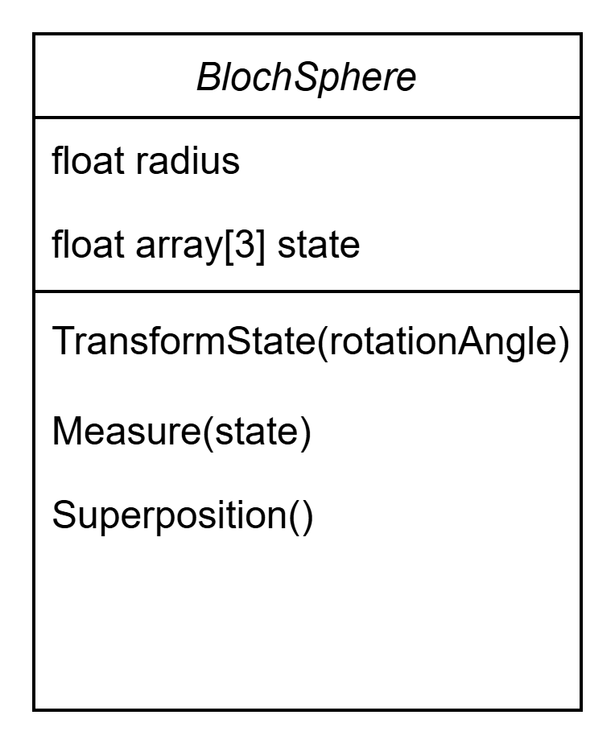

StateVector
This is the arrow that points to the current state co-ordinates on the sphere. It inherits the state attribute from the Bloch Sphere and maps it out graphically. I am modelling this with only one attribute and two methods as such:
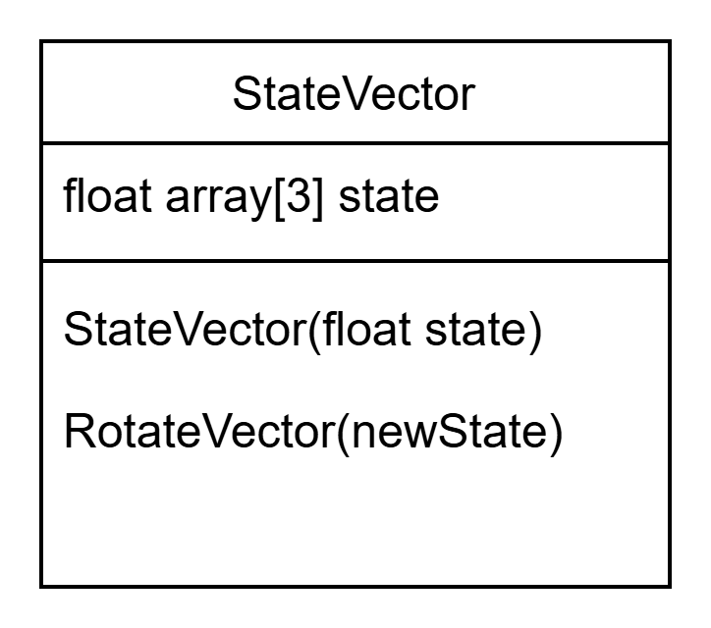

The first method, StateVector(float state) is the instantiation method – method that builds the object. The second method RotateVector(float newState), implements the graphical rotation of the Vector object based on co-ordinates returned from transforming or measuring the qubit object which are discussed in detail later in this document.

The User Interface
This is the medium that allows the user to communicate with the system. Although we discuss this as a separate entity later in the text, we can model the user as an object with input methods:
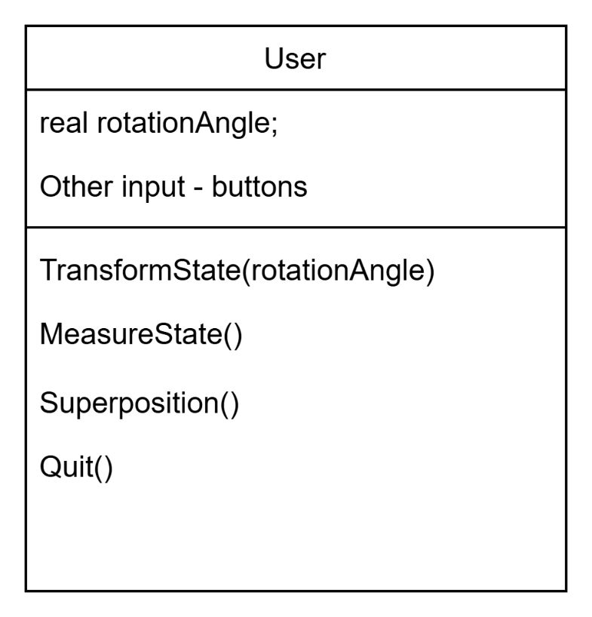

Putting it All Together
The user initiates methods by giving the command via the user interface. These methods will be translated to the qubit, executed and the Qubit responds depending on the results of the computation. The state vector can be viewed as an extension of the qubit that graphically represents states however it must be modelled as an object on its own. The object diagrams can be linked as such:

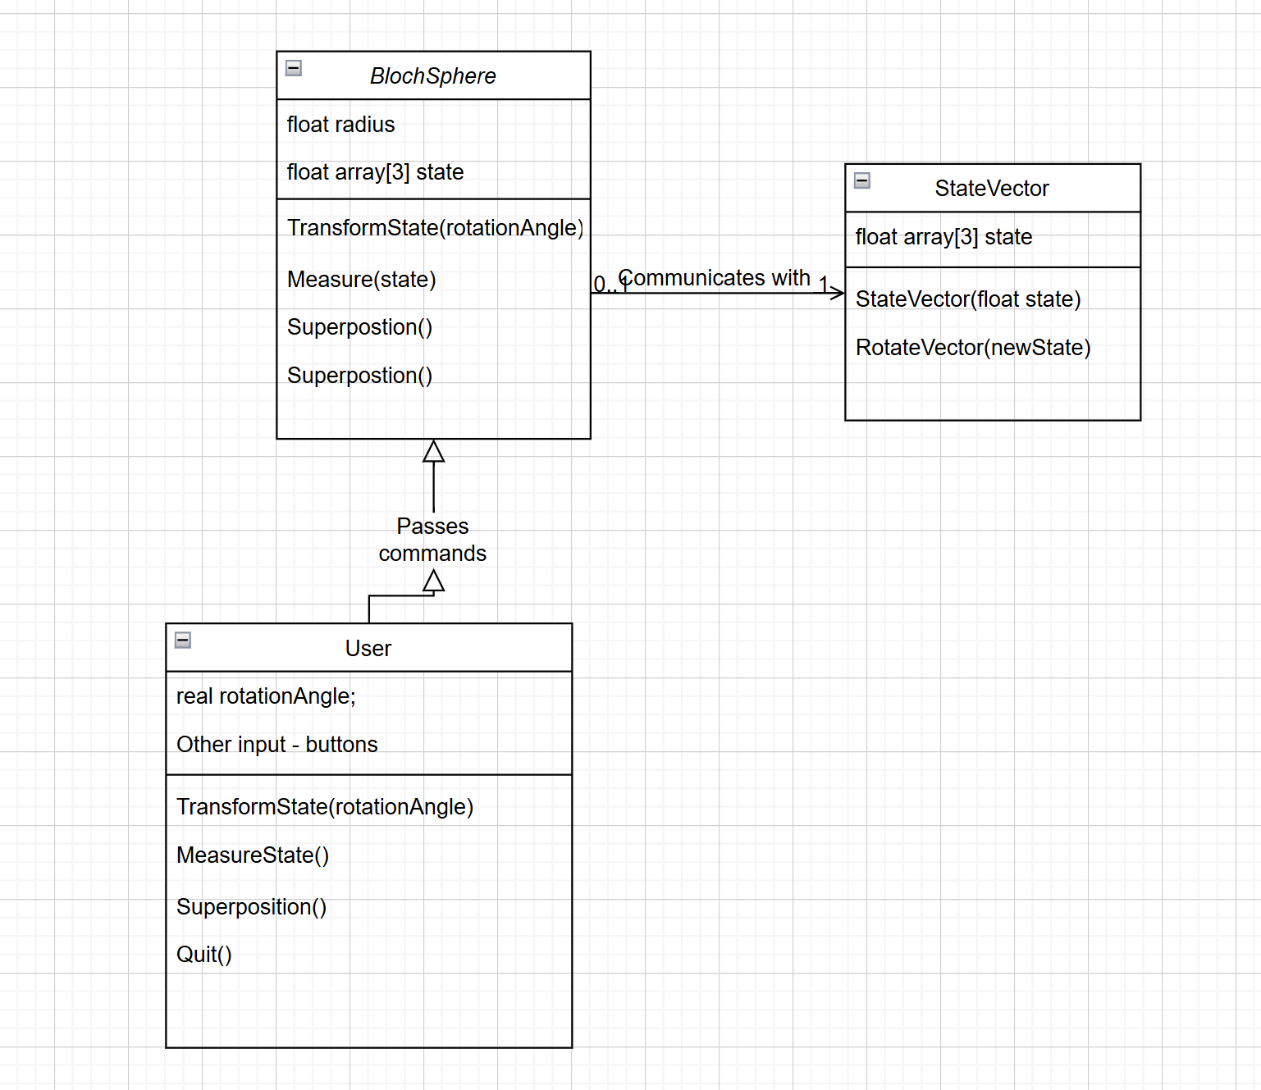

TransformState
This is one of the most important modules of my system. The state of the vector can be represented as a point on the sphere with angles θ and Φ being the angle about the y axis and z axis respectively. The main objective of this module is to perform matrix multiplication on the current state with a combination of the matrix definition of both rotations.
Mathematically:
R(Φ) = rotation around z
R(θ) = rotation around y
Then a full transformation will be:
R(Φ).R(θ)

R(Φ) is defined by the matrix:
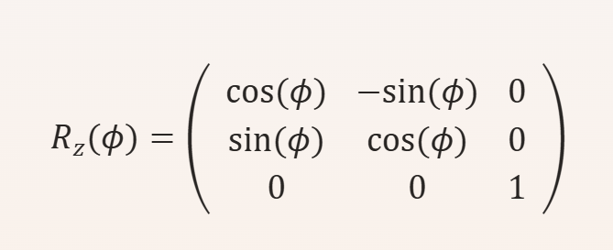

R(θ) is defined by the matrix:
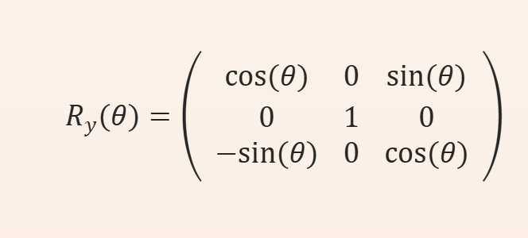
(LibreTexts, 2023)
Objectives of the Module
- Define matrix for rotation about z
- Define matrix for rotation about y
- Define the rotation, FullRotation, that combines both using matrix multiplication
- Perform matrix multiplication on the vector state and return new state
I intended to write a matrix multiplication formula however I found that the python library numpy has an operate “@” that performs matrix multiplication. I believe that this is sufficient for my solution. However, if the program were to be implemented in another language a different library has to be used, or a routine created. It also allows me to create matrices data structures without using python lists and arrays. As user input will be in degrees, it also has a function numpy.radians(angle in degree) that converts degree to radians which will be what the code will be working in.
The following pseudocode can be used as a starting template for this module during design phase:

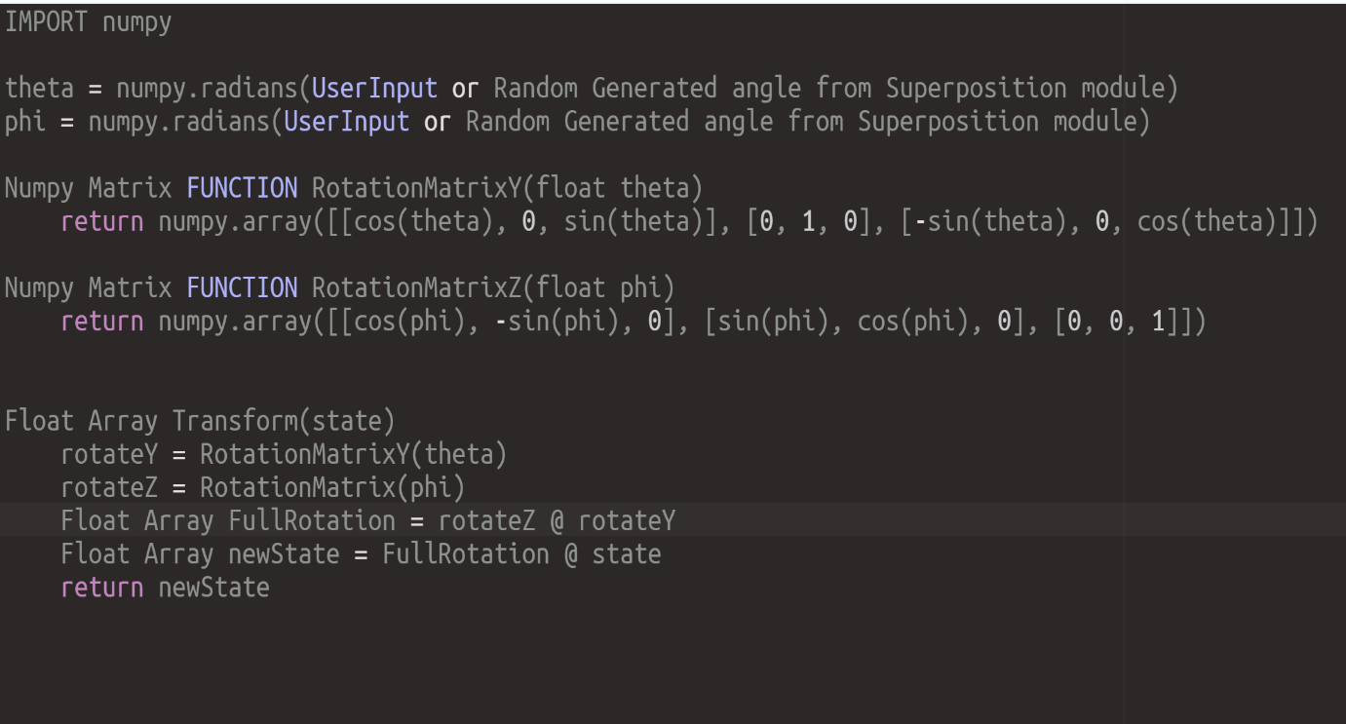
Written with pseudoeditor.com
The trigonometric functions can be used from the numpy library or python math library.
Due to the reliance on modules specific to python the pseudocode has some language specific commands however this can be easily adapted to any programming language which has similar libraries, or these functions and data types must be defined by the implementor.

Superposition
Main Objectives
- Check if state is in Basis State
- If it is not, UI displays message box “Qubit Already in Superposition”
- If it is, generate random angles for theta and phi
- Call StateTransform Module to perform transformation to those states
The Pseudo-Code below can be used as a template to implement this:

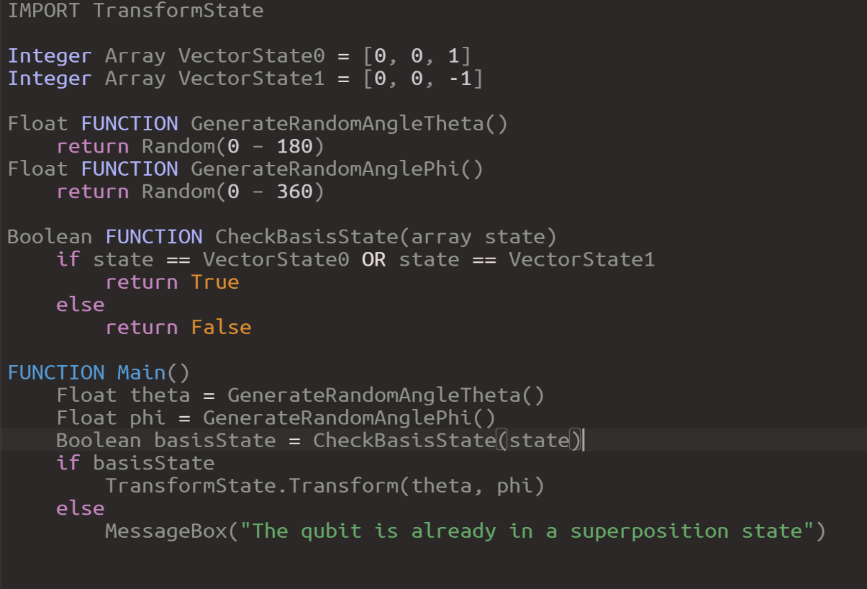
Written with pseudoeditor.com

Measure
A Qubit state ∣ψ⟩ can be modelled with the equation
∣ψ⟩ = cos(θ/2)∣0⟩ + sin(θ/2) e^{i} ^{Φ} ∣1⟩ - A linear combination of both basis states but measurement of the Qubit makes it collapse to one state (Woody, 2022).
Without worrying too much about the complexities, the following equations are also true:
r_{α} = cos(θ/2)
r_{β} = sin(θ/2) (Woody, 2022; IBM, n.d.)
the square of r_{α} represents the probability of the state collapsing on basis state 0 and the square of r_{β} represents the probability of the state collapsing on basis state 1.
Simply put:
r_{α}² = (cos(θ/2))² = Pr(∣0⟩)
r_{β}² = (sin(θ/2))² = Pr(∣1⟩) (Woody 2022; IBM, n.d.)

Since there are only two outcomes, states 1 and 0, we can classify this as a binomial probability. The python library numpy offers a function that calculates binomial probabilities and returns 1 for success and 0 for failure.
numpy.random.binomial(n, p, size) (NumPy, n.d.)
n – this is the number of tries for the binomial probability
p – probability of success
The argument size is optional and does not have any relevance to my solution.
I am adapting this function to my program by calling state 1 success and state 0 failure i.e. if the function returns 0 the measurement yielded state 0 and if the function returns 1 the measurement yielded state 1.
The pseudocode below is a template that can be used in the implementation phase:
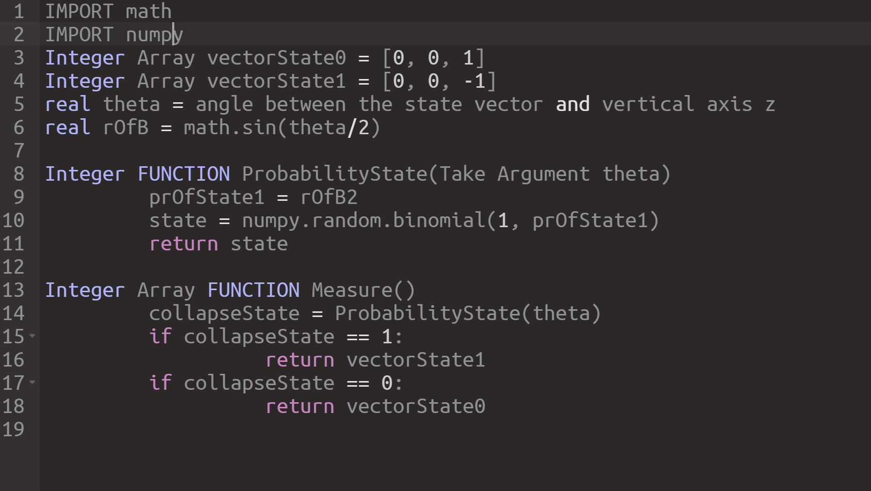
Written with pseudoeditor.com
The problem with this solution is it does not consider normalization which in quantum computing ensures that the sum of the probabilities of all possible states is equal to one. I haven’t found a solution to this yet but will re-evaluate it in my implementation stage or find a way to abstract it from the model.

User Interface
I initially planned to make the User Interface a hybrid of Graphics and terminal as the sketch below:
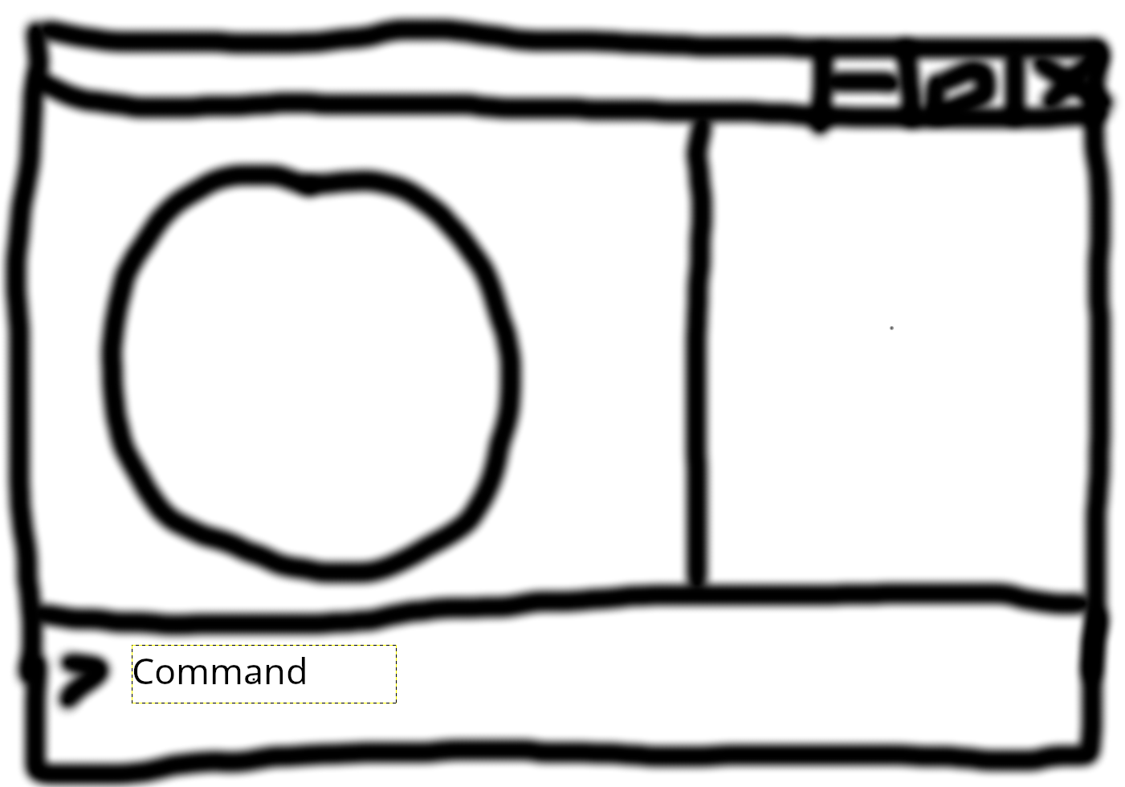

In this setup, the user inputs commands via the command line including 3 by 3 square matrices to perform Transformations to the Qubit. This, however, comes with a problem. If the user inputs a matrix that transforms the vector to a point beyond the surface area of the sphere or within the volume of the sphere that would be an issue as I intend to keep my model in pure-states which are represented as points on the surface of Bloch-sphere in quantum computing.
The solution to this is to ensure that the user is only able to perform a rotation of the state vector – no stretches. Enforcing this constraint with a command line will not be easy as it will require me to give the user the set of matrices they can use and display an error message if they don’t use them. This is not an ideal solution because there are so many wrong matrices the user can input. My solution to this is to drop the command line from the interface and make all the commands graphical – clicking buttons. The new interface will look like the diagram below:
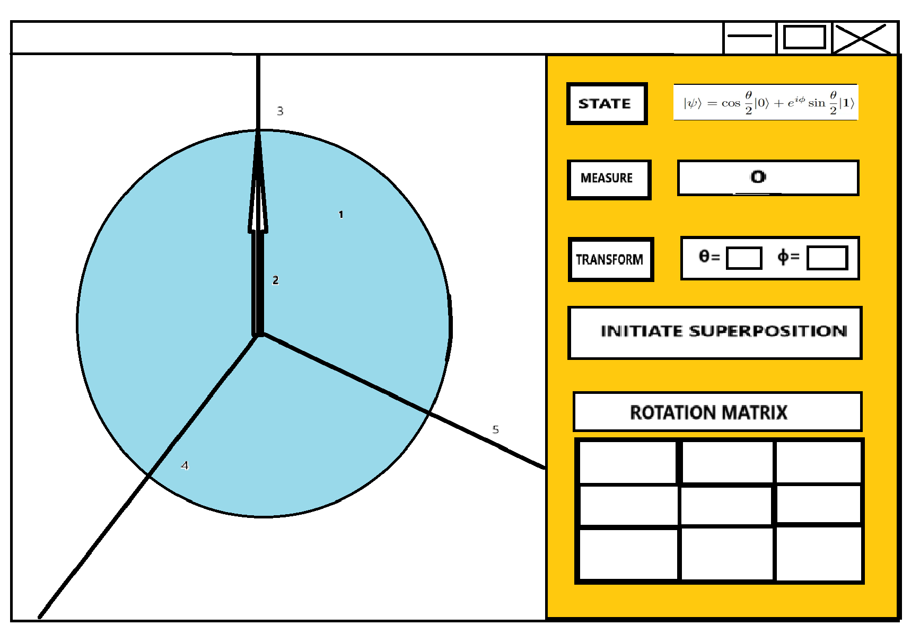

The left side of the application screen will hold the system while the right side will hold the user commands and inputs.
The System section will have a white background, and the sphere (labelled 1) will be light blue. Aside from the pleasing aesthetics, the color contrast allows the user to clearly see the qubit sphere on the simulation plane.
The Arrow (labelled 2) is the state vector object that points to co-ordinates of the current state of the qubit. For now, I have left this as the color white but will re-evaluate during the implementation phase. The lines labelled 3, 4 and 5 are the z, x, and y axis respectively. At the moment, I am not sure if I will include these on the plane but if I do, they will be black. Again, this allows the user to clearly differentiate between the main object – the qubit sphere – and other objects on the screen

The control section of the screen – Right hand side – is coloured orange as this makes it stand out from the system section of the screen.
The state object on the screen displays the state of the qubit in standard quantum computing notation.
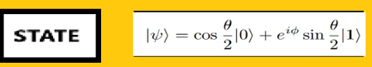

The box containing the string “state” will be clickable. When clicked, a dialog box will appear on the screen explaining the equation to the user:
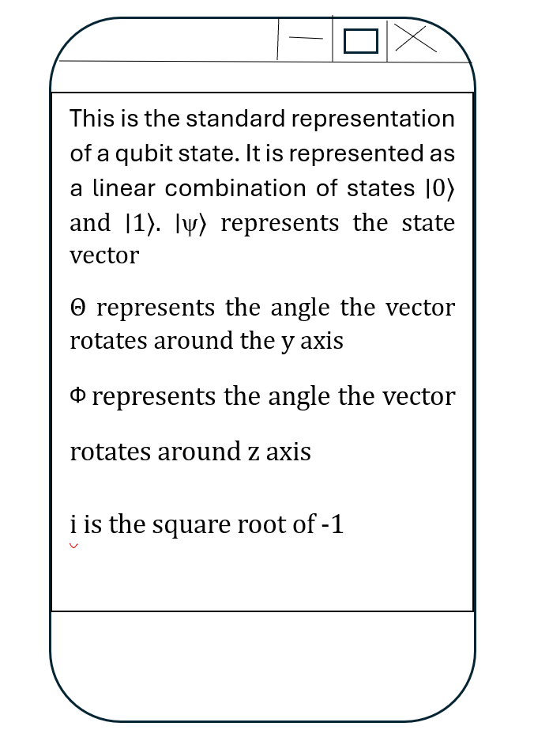

I am including this because the goal of my solution is to aid quantum computing learning for the user therefore explaining confusing concepts is necessary.

The measure object also has a similar setup to the state object.

The box containing the string “Measure” will be clickable. When clicked, the rectangular box beside it will display the result of the measurement based on the probabilistic calculations conducted by the measure module. Here, it displays 0 because the state vector is pointing to zero state so the probability of 0 is 1 – 0 will always be the result of measuring a vector in state 0.
If the vector is in a superposition and the measure command is executed, the Measure module runs and returns state 1 or 0. The state vector will rotate to whichever state the Measurement returns.

The Transform object will also be clickable. Beside it there are two input boxes for θ and Φ allowing the user to input angles in degrees that they want to rotate the vector around the y and z axis respectively with constraints 0 < θ < 180 and 0 < Φ < 360 inclusive.

When the “Transform” button is clicked, the StateTranform module will run based on input from the user and the state vector rotates graphically on the screen.

“Initiate Superposition” is a command to transform the state vector to a randomly generated superposition if the state vector is in one the of basis states 1 or 0. I included this command in case the user cannot decide how many degrees they want to rotate the state vector by.

When clicked, it communicates with the Superposition module to generate random theta and phi values and pass them to the StateTransform module which calculates the new co-ordinates to transform the state vector to.

The Rotation matrix object displays all the entries of the rotation matrix. When the button “Rotation Matrix” is clicked a dialog box will display the following message:

“The rotation matrix is one of the most important matrices in quantum computing. Almost all quantum bit operations involve some form of rotation. In this simulation, all transformations can be expressed as rotations without stretches of the basis state 1 and 0. This ensures that all states represented are points on the surface of the sphere. In quantum computing these are called pure states as opposed to mixed states which are represented as points in the sphere which we do not simulate with this model due to its complexities. You can learn more about pure and mixed states on the internet.”

This dialog box will be similar to the state dialog box. I intend to use the square below it split into 9 squares to represent the rotation matrix. Each square will hold the corresponding value for the rotation matrix in that entry. I have included that in the design but will probably discard it during implementation as it is of no use to the user and just creates more distractions on the interface.
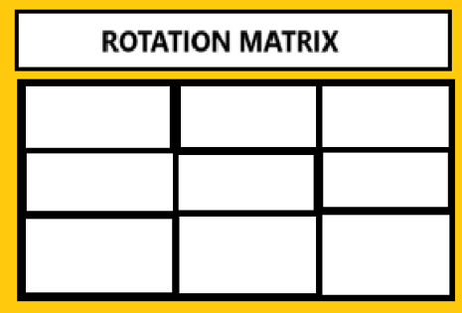

I intend to use either of the python modules tkinter or pygame to implement this UI depending on which one proves more efficient and meets my needs.
I will have another meeting with the end-user before implementing this UI to make sure it satisfies all their needs.

Potential Errors from User Input:
There are only two inputs collected from the user which are the values of the angles θ and Φ in degrees. I intentionally used degrees as input because I am aware that some users of this application will not be familiar with the radians unit system. I will make sure it is clearly stated in the documentation of the program what unit the angles are assumed as by the program.
A potential error is the user trying to enter a non-float datatype. During the implementation stage, I will make a validation function that tests if the input can be converted to float and returns true or false. I will incorporate this function into the UI and ensure that every keystroke is tested, and whichever keystroke does not return true will not be allowed to be entered into the input box.

POST-INTERVIEW 2 DESIGN
Below is a list of questions I asked end user Mr. W. C after the design and their answers:
- Are you satisfied with the decision to change the User interface from command line to Graphical?
Answer: I am completely satisfied with this decision. I believe it will give me a better experience with the simulation.

- Can you suggest some improvements to the UI?
Answer: I’d rather the axis is removed and a display showing the x, y and z coordinates of the simulation, I find the axis distracting. Take away the rotation matrix as well. I also think the state equation is not necessary as I don’t understand it, If I wanted to learn it I’d look it up. Finally, I’d rather the UI uses minimal or non-bright colours to give it a modern look and the line separating the system and the User Interface to be horizontal rather than vertical so that I can focus on one thing at a time.

- Are there any things you think the system is missing?
Answer: I will like more functionality to the system. Now that matrices are not inputted, if you can add some gates I think it will help me understand qubits better.

Key-Takeaways:
- Remove axis and replace it with x, y, z values of state, also remove superposition state equation
- Remove rotation matrix
- Minimalist design
- Separate user interface and system with rows not columns

The interview has prompted me to come up with a new module which is Gates.

Gates
This module will contain 6 functions:
- PualiX(float x, float y, float z)
- PauliY(float x, float y, float z)
- PauliZ(float x, float y, float z)
- PhaseGate(float x, float y, float z)
- TGate(float x, float y, float z)
- HadamardGate(float x, float y, float z)
Inspired by real qubit gates, each function has their respective matrix transformations to perform on the current state rotating it by a specific angle relative to one of the axes (Wong, 2022).
PauliX – 180º about x axis
PauliY - 180º about y axis
PauliZ - 180º about z axis
PhaseGate - 90º about z axis
TGate - 45º about z axis
HadamardGate - 90º about y axis and 180º about y axis

All functions will be a variation of the pseudocode below:
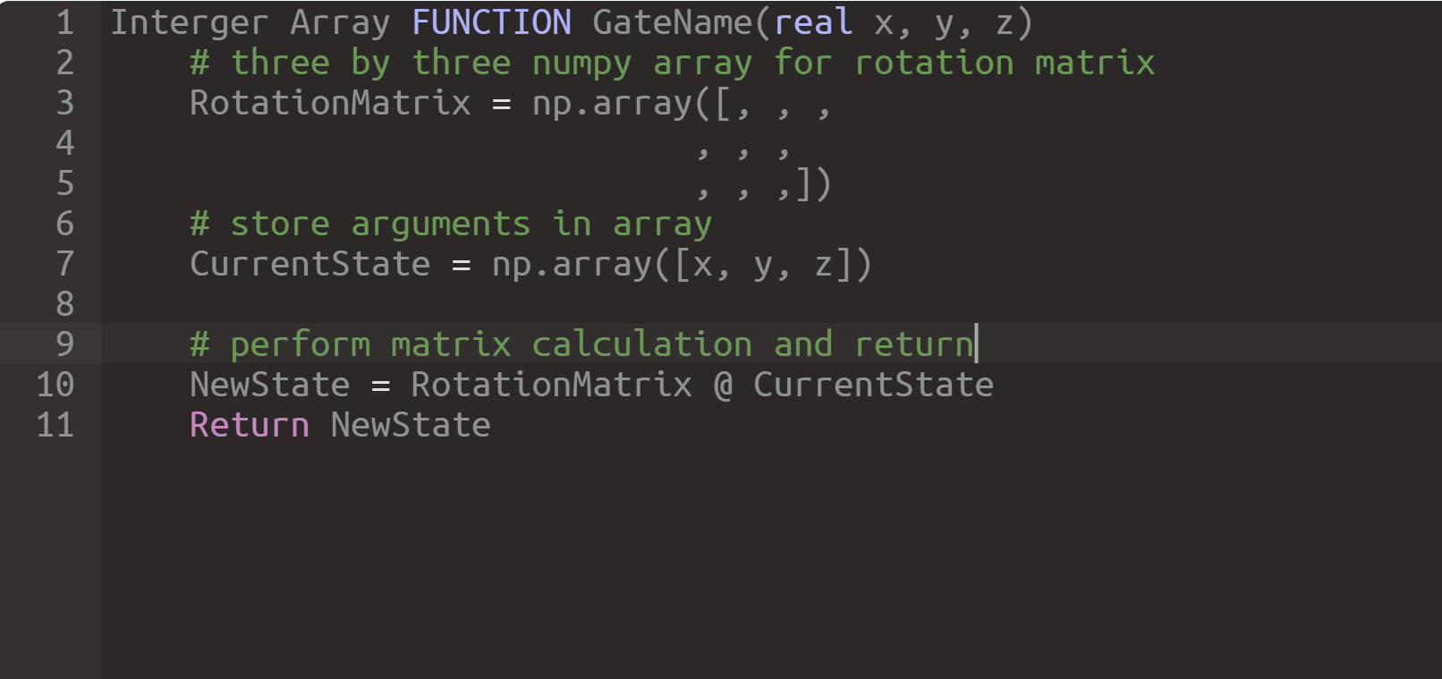
Perform matrix transformation on state using the appropriate matrix and return new state.
The user also suggested a more modern and minimalist interface design. Consequently, I have decided to remove the background colors and maintain the original layout of system at the top and user interface at the bottom:
Qubit Sphere
State Arrow
Transform
Initiate Superposition
Measure
Gates Buttons
θ=
Φ=
Φ=
Current State: x = 0, y = 0, z = 1
Last Measure:
The Display “Current State” will update based on the position of the arrow and another display “Measure” will update to 1 or 0 after user clicks the measure button and return.

Below is a table that shows the intended input/process/output overview of the application:

Input/Button | Process | Output
User enters theta and phi values and | Check that values are within range and entry is not empty, then calculate x, y and z values for new state using the angles entered and return to qubit object | Returns error if value criteria are not met. Otherwise, arrow vector repositions to new state co-ordinates. The current state display updates accordingly.
User clicks measure button | Use binomial to calculate whether to return 0 or 1 based on probability of 1 being cos²(theta) and return result. | Arrow vector positions to state 0 or 1 i.e. due north or south, and measure and current state display updates accordingly.
User clicks Initiate Superposition button | Checks that qubit is not already in superposition then calculates random theta and phi values in the appropriate range and uses the transform module to get new x, y and z values. | Error message displays if qubit is already in superposition. Otherwise, arrow vector repositions and current state display updates accordingly.
User clicks any of the gates button | Apply appropriate matrix rotation on current state and return transformed state. | The Arrow vector repositions to the transformed state and the current state displays updates accordingly.

TECHNICAL SOLUTION
My project was split into 6 Python Files each handling different Modules of the Solution:
- Qubita
- BlochShpere
- Measure
- StateTransform
- SuperPosition
- Gates
The Hierarchy of data flow is as follows:
Qubita
Measure
Gates
SuperPosition
StateTransform
BlochSphere

I built Solution from the Bottom Modules as they Handle the processes of the system. I instinctively used C# naming conventions due to my college using it as the exam language and had already gone far in my project before I realized. The naming convention is, however, consistent throughout.

Measure:
This handles the following processes to execute Objective 3 from Analysis:
- Read current state of qubit
- Calculate which basis state to collapse based on probabilistic state
- Return basis state to collapse to for Qubit Object to continue rest of objectives
- The repositioning and display are implemented with qubit object in later module
The Solution is based on the pseudo code provided in the design section, however there are some minor changes which will be explained
The file contains the following Code:
import math
import numpy as np

# return probability of 1 using maths square method
def POf1(theta):
return math.pow(np.sin(theta/2), 2)

# use numpy Binomial to calculate which state 1 or 0 and return
def ProbableState(theta):
pOfState1 = POf1(theta)
# binomial method takes 1 and probaility of 1 as argument and retruns 1 or 0
state = np.random.binomial(1, pOfState1)
return state

# Measure Function to call from State Class
def Measure(theta):
VECTORSTATE0 = [0, 0, 1]
VECTORSTATE1 = [0, 0, -1]
# get collapsed state
collapsedState = ProbableState(theta)

# return state vector 1 or 0 based on collapsed state
if collapsedState == 1:
return VECTORSTATE1
if collapsedState == 0:
return VECTORSTATE0

From the design it was established that the state 1 probability can be calculated with:
(sin(θ/2))²,
- The function POf1 takes theta as an argument and returns the result of this calculation using the module ‘math’ which the end user will not need to install as it comes with python
- The function ProbableState also takes theta as an argument:
  - Stores the result pOfState1 of calculating the probability of State 1 by passing it to POf1
  - Uses the numpy library class random to return 1 or 0 based on the pOfState1 variable (the numpy library must be installed by any end user of this application as it does not come with python)
  - Stores the result in the variable state and returns it
- The Measure function is the function that will be used by the state class and qubit object later and it takes theta as an argument
  - It declares the Constant List VECTORSTATE0 and VECTORSTATE1 which represent the x, y, z coordinates of the qubit Bloch sphere state 0 and 1
  - Stores the result of ProbableState with parameter theta passed in the variable collapsedState
  - Checks collapsedState is 1 or 0 and returns the appropriate list for 0 or 1

Gates:
The gates module was included due to modifications made to the design after discussing with the end user and they suggested that more functionality is added to the application. For this reason, the objectives of this module were not included during analysis. The objective of this module is to handle the gate execution process of the system i.e. implement the 6 basic Quantum Gates:
- Pauli X gate: this gate is defined by a 180-degree rotation of the current qubit state in the x axis
- Pauli Y gate: this is defined by a 180-degree rotation of the current qubit state in the y axis
- Pauli Z gate: this is defined by a 180-degree rotation of the current qubit state in the z axis
- Phase gate: this is defined by a 90-degree rotation of the current qubit state in the z axis
- T gate: defined by a 45-degree rotation in the z axis
- Hadamard gate: defined by a 90-degree rotation in the y axis and 180-degrees in the x axis
The contained in this module is as follows:
import numpy as np

# @ operator is matrix multiplication in numpy
def PauliX(x, y, z):
#define rotation matrix for x axis with 180-degrees
ROTATION_X_180 = np.array([[1, 0, 0],
[0, np.cos(np.radians(180)), -np.sin(np.radians(180))],
[0, np.sin(np.radians(180)), np.cos(np.radians(180))]])
currentState = np.array([x, y, z])
newState = ROTATION_X_180 @ currentState
return newState

def PauliY(x, y, z):
#define rotation matrix for y axis with 180-degrees
ROTATION_Y_180 = np.array([[np.cos(np.radians(180)), 0, np.sin(np.radians(180))],
[0, 1, 0],
[-np.sin(np.radians(180)), 0, np.cos(np.radians(180))]])
currentState = np.array([x, y, z])
newState = ROTATION_Y_180 @ currentState
return newState

def PauliZ(x, y, z):
#define rotation matrix for z axis with 180-degrees
angle = np.radians(180)
ROTATION_Z_180 = np.array([[np.cos(angle), -np.sin(angle), 0],
[np.sin(angle), np.cos(angle), 0],
[0, 0, 1]])
currentState = np.array([x, y, z])
newState = ROTATION_Z_180 @ currentState
return newState

def PhaseGate(x, y, z):
#define rotation matrix for z axis with 90-degrees
angle = np.radians(90)
currentState = np.array([x, y, z])
ROTATION_Z_90 = np.array([[np.cos(angle), -np.sin(angle), 0],
[np.sin(angle), np.cos(angle), 0],
[0, 0, 1]])
newState = ROTATION_Z_90 @ currentState
return newState

def TGate(x, y, z):
#define rotation matrix for z axis with 45-degrees
angle = np.radians(45)
ROTATION_Z_45 = np.array([[np.cos(angle), -np.sin(angle), 0],
[np.sin(angle), np.cos(angle), 0],
[0, 0, 1]])
currentState = np.array([x, y, z])
newState = ROTATION_Z_45 @ currentState
return newState

def HadamardGate(x, y, z):
#define rotation 90-degree in y axis and 180-degree in x axis
angleY = np.radians(90)
angleX = np.radians(180)
ROTATION_Y_90 = np.array([[np.cos(angleY), 0, np.sin(angleY)],
[0, 1, 0],
[-np.sin(angleY), 0, np.cos(angleY)]])
ROTATION_X_180 = np.array([[1, 0, 0],
[0, np.cos(angleX), -np.sin(angleX)],
[0, np.sin(angleX), np.cos(angleX)]])
currentState = np.array([x, y, z])
newState = ROTATION_Y_90 @ ROTATION_X_180 @ currentState
return newState

Each gate is implemented with a function that takes x, y and z coordinates as, pass them into a 1 by 3 numpy array currentState (a datatype unique to numpy) and calculates the result off multiplying with the appropriate rotation matrix. The rotation matrices are stored using a 3 by 3 numpy array. I used the numpy array data structure because it allows matrix multiplication using the @ operator. A different solution will be defining a function to perform matrix multiplication.
Another thing to note is that I defined the angles and used the method radians() in numpy module to convert the rotation angles to radians. This is because numpy calculations like sin and cos expect the parameter passed to be in radians.
The result of the rotation multiplication is stored in the numpy array newState and returned.
A problem with this solution is the repetition of rotation matrices definitions even though the only change is the angle. One way to avoid this is to model the gates module using OOP methodology and declare the rotation matrices without any angles as attributes. I did not use this approach however because I found the procedural approach more manageable as errors could be easily debugged with individual gate procedures.

StateTransform:
In the analysis, I stated that the user inputs matrix to transform the state however, after researching the problem more, I realized that the user just needs to input two angles theta and phi with theta being the angle between the current state and the z axis and phi the rotation about the z axis. During design, I proposed a pseudocode to solve the problem that involved performing rotation by theta in the y axis and rotation by phi in the z axis using the ROTATIONZ and ROTATIONY matrices. I initially used this solution but quickly realized that I might not have researched or understood the maths properly as it became evident to me that some states are not being reached on the Bloch sphere and the rotation was being performed relative to current state meaning that if an angle is inputted twice by the user, the vector will transform to different states based on its current state. This is, however, a false representation of a qubit system modelled with the Bloch sphere as all states have a unique angle to reach them.
After researching, I found that the x, y and z values of any state can be calculated with the following equations (Wong, 2022):
x = sin(theta) * cos(phi)
y = sin(theta) * sin(phi)
z = cos(theta)
Henceforth, this module executes the following processes from objective 4 in analysis but the implementation is different:
- User inputs Matrix (sin and theta now) to transform state
- Calculate new x, y and z values which will be passed from the Qubit object and return as a list (modification pf performing matrix on point/state)
- The moving process will be implemented by the object

The code below is the content of this module:
import numpy as np

def TransformState(x, y, z, theta, phi):
# convert to radians
theta = np.radians(theta)
phi = np.radians(phi)
# create empty list for new state values and calculate x, y and z
new_state = []
newX = np.sin(theta) * np.cos(phi)
newY = np.sin(theta) * np.sin(phi)
newZ = np.cos(theta)
# pass new value and return
new_state = [newX, newY, newZ]

return new_state

The theta and phi values still had to converted to radians as I was using numpy trigonometry methods.

SuperPosition
This module executes the following procedures from Objective 2 in the Analysis section:
- Define a point on the sphere that is not equivalent to state 1 or 0
- It returns the point defined as the graphing of the vector to that state is done by the qubit object
- The system does not
I used the pseudocode designed from the previous section to implement this, however, there are some slight changes.
import StateTransform
import numpy as np

# define vector list for state 1 and 0 so comparison can be done
VectorState0 = [0, 0, 1]
VectorState1 = [0, 0, -1]
ErrorMessage = "The Qubit is already in a superposition state"

# define functions to generate random angles
def GenerateRandomAngleTheta():
theta = 0
# loop to ensure that it does not return a Base State as the random angle
while theta == 0 or theta == 180:
theta = np.random.uniform(0.0, 180.0)
return theta
def GenerateRandomAnglePhi():
# this angle defines the latitude so it does not affect the base state
return np.random.uniform(0.0, 360.0)

# function to ensure that the state passed is not already in superposition
def CheckBasisState(stateVector):
if stateVector == VectorState0 or stateVector == VectorState1:
return True
else:
return False

# function to call in StateVector class
def SuperPosition(stateX, stateY, stateZ):
theta = GenerateRandomAngleTheta()
phi = GenerateRandomAnglePhi()
state = [stateX, stateY, stateZ]
basisState = CheckBasisState(state)
if basisState:
newState = StateTransform.TransformState(theta, phi)
return newState, theta
else:
return ErrorMessage

I imported the StateTransform module because I later used it to transform the state based on randomly generated angles.
- The functions GenerateRandomAngleTheta and GenerateRandomAnglePhi return values for theta using the method uniform from the random class in numpy’s module. For theta it has to be any float value between 0 and 180 non inclusive as angle 0 and 180 define states 0 and 1. This is why I used the if value because the uniform function is inclusive and I did not want a case where the generated superposition state is 0 or 1. The phi did not need this fail safe method as it does not determine states 0 or 1 if there has already been a caution which is being taken with the theta generator
- The CheckBasisState function takes a list stateVector as argument and ensures it is in a superposition state by comparing it to one of the basis states 0 or 1 and returns true or false
- The SuperPosition function is the one that is called later by the State object, and it takes x, y and z coordinates as arguments
  - It defines theta and phi and uses the GenerateRandomAngle functions to get them
  - Place the x, y, z values in a python list state; I could have collected the numpy array as an argument, but I just found collecting x, y, z values and using a python list more manageable.
  - The state is passed to the CheckBasisState function and stored in a boolean basisState
  - A conditional is used to check is it is basis state or not and if it is it calls the TransformState function from the StateTransform module and passes the randomly generated angles as parameters storing the returned result in a variable newState
  - It returns newState and theta to ensure that the proper theta value for measure is used later in the State class
  - Else it returns an error string

BlochSphere
This module contains the Qubit sphere class and state class. To properly implement it, I had imported all the libraries I had made and numpy as there were some Methods I needed to use in numpy.
from mpl_toolkits.mplot3d import Axes3D
import numpy as np
import matplotlib.pyplot as plt
from StateTransform import *
import Measure
import SuperPosition
import Gates

I imported matplotlib plt to test that the BlochSphere and StateVector plot properly and methods work. In my initial design, I intended to use pyopengl to render the state and qubit objects, however I changed back to my proposed solution in the analysis section of using matplotlib and this decision will be further explained in the Qubita solution section. The classes implemented in this file are BlochSpere and StateVector.
BlochSphere: This was later instantiated as the Qubit sphere object:
The code below is the implementation of this class:
class BlochSphere:
# define matrices for azimuthal and polar angle on grid
az, pol = np.mgrid[0:2*np.pi:20j, 0:np.pi:20j] # define matrices for azimuthal angle on grid
def __init__(self, radius):
self.r = radius
# initiate x, y, z values for sphere plot
self.x = radius*np.sin(self.pol)*np.cos(self.az)
self.y = radius*np.sin(self.pol)*np.sin(self.az)
self.z = radius*np.cos(self.pol)
The numpy mgrid data structure returns all the possible points scattered across a defined range and stores them. I have used the azimuthal angle (az variable) and polar angle (pol variable) to define it:
az, pol = np.mgrid[0:2*np.pi:20j, 0:np.pi:20j]

The statement above means:
- Define numpy mgrid (mesh grid) data types az and pol
- For az store all the values from 0 – 2pi (2*np.pi)
- For pol store all values from 0 – pi.
- “20j” defines how dense or spread out the points should be. A higher value would yield closer values making the plot look smoother. I found 20j to be the best value as the system got slower to rotate with higher values and low resolution with lower values.
The __init__ function is python’s constructor which must have self as an argument, I passed radius as an argument to make the solution a more general sphere solution but this could be completely disregarded and radius can be set to 1 because Quantum bits are mathematically modelled with a unit sphere (sphere with radius 1). It initializes attributes x, y, and z. The equation set defines all the x, y, z values required to plot a sphere. Because of the way numpy’s mesh grid data structure is implemented, all the az and pol values will used in the equation and stored in x, y and z for plotting later.

StateVector
This Class contains most of the process functionalities of the simulation system. It uses functions from the other modules to define all the operations on the state of the qubit that are modelled with this system.
class StateVector:
# declare constant numpy array for origin to plot vector state later
VECTORTAIL = np.array([0, 0, 0])
def __init__(self, x=float, y=float, z=float): # constructor for state vector collects x, y and z
# ensures that all values of are between -1 and 1 for easy debugging during instantiation
assert -1 <= x <= 1, "all values must be between -1 and 1"
assert -1 <= y <= 1, "all values must be between -1 and 1"
assert -1 <= z <= 1, "all values must be between -1 and 1"
# vector state has to be a 2d array
self.vectorState = np.array([x, y, z])
self.theta = 0
self.phi = 0

# Call Transform State Function from StateTransform module to return new state
# take theta and pi as argument which will be passed by user
def RotateVector(self, theta, phi):
newState = TransformState(
theta,
phi)
# set theta argument value to pass to measure later and set vector state x, y, z values from new state
self.theta = theta
self.vectorState = [newState[0], newState[1], newState[2]]

# Measuring function from measure module, return collapse state and set vector State to it
def Measure(self):
# pass the theta attribute as argument
collaspeState = Measure.Measure(self.theta)
self.vectorState = np.array([collaspeState[0],
collaspeState[1],
collaspeState[2]])
# change theta to 0 if collapsed state is 0 or 180 if state is 1
if self.vectorState[2] == 1:
self.theta = 0
elif self.vectorState[2] == -1:
self.theta = 180

# Super Position funtion from superposition module
def InitSuperposition(self):
# check if it returned error message i.e. Already in Superposition, to ensure string returned is not passed to vector state
if type(SuperPosition.SuperPosition(self.vectorState[0],
self.vectorState[1],
self.vectorState[2])) == str:
# return the message to be used by error message box later
return SuperPosition.SuperPosition(
self.vectorState[0],
self.vectorState[1],
self.vectorState[2])
newState, self.theta = SuperPosition.SuperPosition(
self.vectorState[0],
self.vectorState[1],
self.vectorState[2])
self.vectorState = np.array([newState[0], newState[1], newState[2]])

# Pauli X gate from gates module
def PauliX(self):
# pass vectorState x, y and z values as argument store result in state attibute
newState = Gates.PauliX(self.vectorState[0],
self.vectorState[1],
self.vectorState[2])
self.vectorState = np.array([newState[0], newState[1], newState[2]])
# get the theta value for measure using z = cos(theta) so theta = arccos(z) of th new gate state
self.theta = np.arccos(self.vectorState[2]) # get theta value from z

# Pauli Y gate from gates module
def PauliY(self):
newState = Gates.PauliY(self.vectorState[0],
self.vectorState[1],
self.vectorState[2])
self.vectorState = np.array([newState[0], newState[1], newState[2]])
self.theta = np.arccos(self.vectorState[2])

# Pauli Z gate from gates module
def PauliZ(self):
newState = Gates.PauliZ(self.vectorState[0],
self.vectorState[1],
self.vectorState[2])
self.vectorState = np.array([newState[0], newState[1], newState[2]])
self.theta = np.arccos(self.vectorState[2])

# PhaseGate from gates module
def PhaseGate(self):
newState = Gates.PhaseGate(self.vectorState[0],
self.vectorState[1],
self.vectorState[2])
self.vectorState = np.array([newState[0], newState[1], newState[2]])
self.theta = np.arccos(self.vectorState[2])

# TGate from gates module
def TGate(self):
newState = Gates.TGate(self.vectorState[0],
self.vectorState[1],
self.vectorState[2])
self.vectorState = np.array([newState[0], newState[1], newState[2]])
self.theta = np.arccos(self.vectorState[2])

# HadamardGate from gates module
def HadamardGate(self):
newState = Gates.HadamardGate(self.vectorState[0],
self.vectorState[1],
self.vectorState[2])
self.vectorState = np.array([newState[0], newState[1], newState[2]])
self.theta = np.arccos(self.vectorState[2])

- The constant VECTORSTATE stores the origin of the plane to plot the vector from in the Qubita module later
- __init__ (constructor) takes x, y and z arguments and I later pass 0, 0, 1, the x, y, z values for basis state 0.
  - assert is a debug failsafe to ensure I do not get confused by passing wrong values during the instantiation (the vector cannot be more that 1 or less than –1 because it will be beyond the spheres enclosure).
  - It creates an attribute vector state that stores the current qubit state. This is set as a numpy array with 3 elements representing x, y, and z values.
  - theta and phi attributes are set to 0 to be updated based with later methods
- RotateVector method takes user input theta and phi as arguments and passes them to the TransformState function from StateTransform module.
  - The results are stored in a python list which is used to update the vectorState attribute.
  - theta attribute is updated to the theta passed as argument to be used by measure later
- Measure method takes no argument because the attribute updates as the user inputs it. The Measure function from Measure module takes the theta attribute as argument and stores the result in the list collapseState which updates the vectorState attribute to basis state 0 or 1
  - A conditional checks the result of the measurement by comparing the z index (index 2) to 1 and –1 (state 0 and 1) and updates the theta value to ensure that it is appropriately configured.

- InitSuperposition takes no arguments no user input is required.
def InitSuperposition(self):
# check if it returned error message i.e. Already in Superpostion, to ensure string returned is not passed to vector state
if type(SuperPosition.SuperPosition(self.vectorState[0],
self.vectorState[1],
self.vectorState[2])) == str:
# return the message to be used by error message box later
return SuperPosition.SuperPosition(
self.vectorState[0],
self.vectorState[1],
self.vectorState[2])
newState, self.theta = SuperPosition.SuperPosition(
self.vectorState[0],
self.vectorState[1],
self.vectorState[2])
self.vectorState = np.array([newState[0], newState[1], newState[2]])

  - Recall that the SuperPosition function from superposition module returns an error message or a randomly generated superposition state as an x, y, z list and the theta angle used to generate that state
  - The condition in this method checks the type returned by SuperPosition, if it is a string, then it returns the error message to be displayed, if not, it updates the vectorState attribute with the x, y, z values in the new randomly generated state and updates the theta attribute to the value returned

- The remaining methods are implemented with functions in the Gates module.
  - All methods store the returned result of their appropriate functions from the gates module in the list newState
  - The 0 – 2 indexes of newState represent x, y, z values for the new state as a result of applying any of the gates to the current state. Recall that the gates take x, y, z values as parameters and vectorState stores the endpoint of the vector from origin 0. For this reason, indexes 0, 1, 2 are passed as arguments as they represent the appropriate values
  - theta attribute is updated using the equation z = cos(theta) therefore theta = arccos(z). This is because the values that the gate transforms the state to is relative and so this is the only way the appropriate value theta for measurement can be calculated

I did some testing to ensure that the classes and methods properly work with the following code:
def main():
Qubit = BlochSphere(1)
QubitState = StateVector(0, 0, 1)
#QubitState.InitSuperposition()
QubitState.RotateVector(90, 180)
#QubitState.Measure(QubitState.theta)
fig = plt.figure()
ax = fig.add_subplot(111, projection="3d")
# plot origin to allow user to easily track state vector at 0,0,0 using ax.scatter
ax.scatter([0], [0], [0], color='r', s=50)
ax.plot_wireframe(Qubit.x, Qubit.y, Qubit.z, color="b", alpha=0.3)
ax.quiver(QubitState.VECTORTAIL[0], QubitState.VECTORTAIL[1], QubitState.VECTORTAIL[2],
QubitState.vectorState[0], QubitState.vectorState[1], QubitState.vectorState[2],
color = 'r', arrow_length_ratio = 0.20)
plt.show()
QubitState.RotateVector(70, 760)
ax.quiver(QubitState.vector_tail[0], QubitState.vector_tail[1], QubitState.vector_tail[2],
QubitState.vectorState[0], QubitState.vectorState[1], QubitState.vectorState[2],
color = 'r', arrow_length_ratio = 0.20)
plt.show()

if __name__ == "__main__":
main()

The following code creates a Qubit object using the BlochSphere class and a qubit state object using the StateVector objects, creates a matplotlib figure and axis and plots them. The plotting process will be explained in detail in the next section. I used this to check that the methods properly worked and deleted after all tests were passed as all the plotting and replotting were done in the Qubita file.

Qubita
This is the main file and it contains the Qubita class, object, and user interface design.
from BlochSphere import *
import tkinter as tk
from tkinter import ttk
from tkinter import messagebox
import matplotlib.pyplot as plt
from matplotlib.backends.backend_tkagg import FigureCanvasTkAgg

I imported the BlochSphere class for the Qubita class to inherit attributes and methods from BlochSphere (qubita sphere class) and StateVector (qubita state class).
Tkinter is python’s GUI, I also imported ttk for as it has more modern looking widgets which was something the user mentioned in interview 2. messagebox is used to display error messages.
plt from matplotlib is used to create the matplotlib figure and axis to plot the sphere and state. FigureCanvasTkAgg is used to place the plot into the tkinter GUI, this will be explained in detail later.

Qubita Class
This inherits all the BlochSphere and StateVector class. Instantiating this class executes the first and second procedure in objective 1
- Create Bloch sphere object and graph it on 3d plane
- Initialize basis state to be 1 or 0 (I initialized as 0 in all cases)
# Qubita Class Inherits all the Sphere and Vector State attributes and plots on MatPlotlib Figure
class Qubita(BlochSphere, StateVector):
def __init__(self, QubitaRadius, x=float, y=float, z=float):
# pass initial parameters to Super classes
BlochSphere.__init__(self, QubitaRadius)
StateVector.__init__(self, x, y, z)

# Plot State and Qubit Sphere
self.fig = plt.figure()
self.ax = self.fig.add_subplot(111, projection="3d")
self.ax.scatter([0], [0], [0], color='r', s=50)
self.QubitSphere = self.ax.plot_wireframe(self.x, self.y, self.z, color="b", alpha=0.3) # Sphere plot
self.Vector = self.ax.quiver(self.VECTORTAIL[0], self.VECTORTAIL[1], self.VECTORTAIL[2],
self.vectorState[0], self.vectorState[0], self.vectorState[2],
color = 'r', length=1, normalize=True, arrow_length_ratio = 0.20)
self.ax.axis('off')

# Inherit rotate vector from StateVector class and plot
def RotateVector(self, theta, phi):
StateVector.RotateVector(self, theta, phi)
self.Vector.remove()
self.fig.canvas.draw_idle()
self.Vector = self.ax.quiver(self.VECTORTAIL[0], self.VECTORTAIL[1], self.VECTORTAIL[2],
self.vectorState[0], self.vectorState[1], self.vectorState[2],
color = 'r', length=1, normalize=True, arrow_length_ratio = 0.20)
#print(self.vectorState)
#print(vector)

# inherit Measure from Statevector class and plot
def Measure(self):
StateVector.Measure(self)
self.Vector.remove()
self.fig.canvas.draw_idle()
self.Vector = self.ax.quiver(self.VECTORTAIL[0], self.VECTORTAIL[1], self.VECTORTAIL[2],
self.vectorState[0], self.vectorState[1], self.vectorState[2],
color = 'r', arrow_length_ratio = 0.20)

# Inherit InitSuperposition from state vector class and plot
def InitSuperposition(self):
StateVector.InitSuperposition(self)
self.Vector.remove()
self.fig.canvas.draw_idle()
self.Vector = self.ax.quiver(self.VECTORTAIL[0], self.VECTORTAIL[1], self.VECTORTAIL[2],
self.vectorState[0], self.vectorState[1], self.vectorState[2],
color = 'r', length=1, normalize=True, arrow_length_ratio = 0.20)

# Inherit All gate methods from StateVector class and plot
def PauliX(self):
StateVector.PauliX(self)
self.Vector.remove()
self.fig.canvas.draw_idle()
self.Vector = self.ax.quiver(self.VECTORTAIL[0], self.VECTORTAIL[1], self.VECTORTAIL[2],
self.vectorState[0], self.vectorState[1], self.vectorState[2],
color = 'r', length=1, normalize=True, arrow_length_ratio = 0.20)

def PauliY(self):
StateVector.PauliY(self)
self.Vector.remove()
self.fig.canvas.draw_idle()
self.Vector = self.ax.quiver(self.VECTORTAIL[0], self.VECTORTAIL[1], self.VECTORTAIL[2],
self.vectorState[0], self.vectorState[1], self.vectorState[2],
color = 'r', length=1, normalize=True, arrow_length_ratio = 0.20)

def PauliZ(self):
StateVector.PauliZ(self)
self.Vector.remove()
self.fig.canvas.draw_idle()
self.Vector = self.ax.quiver(self.VECTORTAIL[0], self.VECTORTAIL[1], self.VECTORTAIL[2],
self.vectorState[0], self.vectorState[1], self.vectorState[2],
color = 'r', length=1, normalize=True, arrow_length_ratio = 0.20)

def PhaseGate(self):
StateVector.PhaseGate(self)
self.Vector.remove()
self.fig.canvas.draw_idle()
self.Vector = self.ax.quiver(self.VECTORTAIL[0], self.VECTORTAIL[1], self.VECTORTAIL[2],
self.vectorState[0], self.vectorState[1], self.vectorState[2],
color = 'r', length=1, normalize=True, arrow_length_ratio = 0.20)

def TGate(self):
StateVector.TGate(self)
self.Vector.remove()
self.fig.canvas.draw_idle()
self.Vector = self.ax.quiver(self.VECTORTAIL[0], self.VECTORTAIL[1], self.VECTORTAIL[2],
self.vectorState[0], self.vectorState[1], self.vectorState[2],
color = 'r', length=1, normalize=True, arrow_length_ratio = 0.20)

def HadamardGate(self):
StateVector.HadamardGate(self)
self.Vector.remove()
self.fig.canvas.draw_idle()
self.Vector = self.ax.quiver(self.VECTORTAIL[0], self.VECTORTAIL[1], self.VECTORTAIL[2],
self.vectorState[0], self.vectorState[1], self.vectorState[2],
color = 'r', length=1, normalize=True, arrow_length_ratio = 0.20)

def __init__(self, QubitaRadius, x=float, y=float, z=float):
# pass initial parameters to Super classes
BlochSphere.__init__(self, QubitaRadius)
StateVector.__init__(self, x, y, z)

# Plot State and Qubit Sphere
self.fig = plt.figure()
self.ax = self.fig.add_subplot(111, projection="3d")
self.ax.scatter([0], [0], [0], color='r', s=50)
self.QubitSphere = self.ax.plot_wireframe(self.x, self.y, self.z, color="b", alpha=0.3) # Sphere plot
self.Vector = self.ax.quiver(self.VECTORTAIL[0], self.VECTORTAIL[1], self.VECTORTAIL[2],
self.vectorState[0], self.vectorState[0], self.vectorState[2],
color = 'r', length=1, normalize=True, arrow_length_ratio = 0.20)
self.ax.axis('off')

The constructor __init__ takes radius and x, y, z values as parameters and passes the appropriate values to BlochSphere and StateVector constructors.
- It creates a figure and 3d axis attribute to allow plotting, unplotting and replotting
- Plots the origin as a scatter dot for user to easily track the tail of the state vector
- It also plots a blue sphere using the generated mesh grid of x, y and z values in BlochSphere class using plot_wireframe() a method of the created axis and stores it in the attribute QubitSphere. I wanted to use the plot_surface() method however I found that it was less aesthetically pleasing and getting in the way of the plotted state vector.
- Plot the state using the vectorState attribute from StateVector class and store it in the variable Vector. This will later be instantiated with x=0, y=0, z=1 (state 0). I used the axis quiver() method and plotted the VECTORTAIL constant (0, 0, 0) in StateVector as the tail of the Vector. I set color to red to make it stand out from the sphere. I made the length to always be equal to 1 ensuring that the vector does not extend beyond the surface of the sphere.
- I set axis off as this was a request from the user in Interview 2. They said the axis is too distracting and they’d rather have a display showing the current x, y, z values of the vector

The remaining methods are polymorphs of methods from StateVector class. They run StateVector methods and al contain the following lines:
self.Vector.remove()
self.fig.canvas.draw_idle()
self.Vector = self.ax.quiver(self.VECTORTAIL[0], self.VECTORTAIL[1], self.VECTORTAIL[2],
self.vectorState[0], self.vectorState[1], self.vectorState[2],
color = 'r', length=1, normalize=True, arrow_length_ratio = 0.20)

This ensures that the common procedure in Objectives 2, 3, 4 and 5 is met:
- Move/reposition vector arrow to collapsed/new state

The first line removes the Vector from the plot. The draw_idle() method makes sure the figure can redraw autonomously (without user intervention like mouse clicks etc.) The final line resets the Vector attribute to a new plot based on the results of the vectorState from running the inherited method.

main()
The main function controls the Input-Process-Output flow of the system. There are 9 run functions (one for each user button) and two validation functions which will be explained in detail later.

# Create Qubita Window and Qubit object by instatiating Qubita Class
Qubit = Qubita(1, 0, 0, 1)
QubitaWindow = tk.Tk()
QubitaWindow.title("Qubita")
QubitaWindow.iconbitmap('QUBITA ICON.ico')
QubitaWindow.rowconfigure(0, weight=1)
QubitaWindow.rowconfigure(1, weight=2)
QubitaWindow.columnconfigure(0, weight=1)

The lines above create a qubit object and initializes it to state 0. It also initializes the Qubita window with two rows; and one column; row 0 for the qubit object and row 1 for the user buttons. This is as requested by the user in interview 2. The title is set and an icon which is stored in the same directory as the project files is configured.

# Qubit in Qubita Window
qubitObjectFrame = tk.Frame(master=QubitaWindow)
canvas = FigureCanvasTkAgg(Qubit.fig, master=qubitObjectFrame)
canvas.draw()
# canvas widget
canvas_widget = canvas.get_tk_widget()
canvas_widget.pack(expand=True, fill='both')
qubitObjectFrame.grid(row=0, column=0, sticky='nsew')

The lines above insert the plot initialized by creating the Qubit object.
- Creates a qubit object frame
- Creates a tkinter canvas to place the figure using the method FigureCanvasTkAgg() which was imported in earlier lines, the fig attribute of Qubit object is passed
- A widget (tkinter object) is created using the with the canvas
- The canvas is packed to fill up the qubit object frame
- The qubit object frame is set to occupy row 0 (top row)
# create validation variables for user inputs using the functions
validatetheta = (QubitaWindow.register(ValidateTheta), '%P')
validatephi = (QubitaWindow.register(ValidatePhi), '%P')
error_msg = tk.StringVar()

These configure the validation values to be used by the user input widgets. It also configures a variable for some input error messages.

# User Interface Frame
userInterfaceMasterFrame = ttk.Frame(master=QubitaWindow)
userInterfaceFrame = tk.Frame(master=userInterfaceMasterFrame, borderwidth=2, relief='solid')
userInterfaceFrame.rowconfigure(0, weight=1)
userInterfaceFrame.rowconfigure(1, weight=1)
userInterfaceFrame.rowconfigure(2, weight=1)
userInterfaceFrame.rowconfigure(3, weight=1)
userInterfaceFrame.rowconfigure(4, weight=1)
userInterfaceFrame.columnconfigure(0, weight=1)
The code above configures a user interface frame with 5 rows and column to place buttons.

# Current state and Last measure label
currentState = f"Current State: x = {Qubit.vectorState[0]}, y = {Qubit.vectorState[1]}, z = {Qubit.vectorState[2]}" # string to pass
currentStateAndMeasureResultFrame = ttk.Frame(master=userInterfaceFrame)
measureLabel = ttk.Label(master=currentStateAndMeasureResultFrame,
font = 'Calibri 12',
text = "Last Measure: "
)
currentStateLabel = ttk.Label(master=currentStateAndMeasureResultFrame, font='Calibri 12', text=currentState)
currentStateLabel.pack()
measureLabel.pack()
currentStateAndMeasureResultFrame.grid(row=0, column = 0)

The code above creates a frame currrentStateAndMeasureResultFrame for the for two display labels: measureLabel and currentStateLabel.
- The measure label shows the result of the last measure (1 or 0) if the measure.
- The current state label shows the x, y and z values for whatever state the state vector is in at any given time. The variable currentState stores the text that is displayed by this label, and it contains takes the vectorState attribute of the Qubit object index 0, 1 and 2 for x, y and z respectively
- Both labels are packed into the frame meaning that they are placed at the in respective order at the top of the frame and the frame is placed in row 0 of the userInterfaceFrame.

# Transform Frame
transformFrame = ttk.Frame(master=userInterfaceFrame)
thetaLabel = ttk.Label(master=transformFrame, text="θ = ")
thetaEntry = ttk.Entry(master=transformFrame,
validate="key",
validatecommand=validatetheta)
phiLabel = ttk.Label(master=transformFrame, text="φ = ")
phiEntry = ttk.Entry(master=transformFrame,
validate="key",
validatecommand=validatephi)

transformButton = ttk.Button(master=transformFrame,
text="Transform", width=20,
command=RunTransform)
errorLabel = tk.Label(master = transformFrame, text='')
transformButton.pack(side='left')
thetaLabel.pack(side='left')
thetaEntry.pack(side='left')
phiLabel.pack(side='left')
phiEntry.pack(side='left')
errorLabel.pack(side='top')
transformFrame.grid(row=1, column=0)

This is the creates a frame transformFrame for all the widgets for transforming the Qubit state.
- The thetaLabel displays the text ‘θ =’ indicating to the user that the entry box next to it is for theta values.
- phiLabel does the same thing for phi.
- thetaEntry and phiEntry are the entry values that take theta and phi values respectively. The validate command is set to the appropriate validation variable as defined previously i.e. validatetheta and validatephi.
- The validation is set to ‘key’ meaning that the validation is ran for every key pressed and won’t take values that don’t match the definitions in the functions that will be properly explained later
- The transformButton initiates the function RunTransform which will be explained in detail later.
- An errorLabel is also configured to display to the user what error is causing the entry to reject their value so that they can fix it. It is initialized as an empty string
- These are all packed into a frame, transformFrame which is positioned in row 1 of the userInterfaceFrame

# Measure and superposition button
measureSuperpositionFrame = ttk.Frame(master=userInterfaceFrame)
measureButton = ttk.Button(master=measureSuperpositionFrame,
text="Measure",
width=20,
command=RunMeasure)
superpositionButton = ttk.Button(master=measureSuperpositionFrame,
text="Initiate Superposition",
width=20,
command=RunSuperpostion)
measureButton.pack(side='left')
superpositionButton.pack(side='right')
measureSuperpositionFrame.grid(row=2, column=0)

The following code creates a frame for the measure and superposition button
- Measure button widget is created and linked to a function that runs the Qubit Measure() method.
- Superposition button widget is created and linked to runs the Qubit InitSuperposition() method.
- Both widgets are packed into the frame which is positioned in row 2 of the userInterfaceFrame.

# Gates Frame
gatesFrame = ttk.Frame(master=userInterfaceFrame)
pauliXButton = ttk.Button(master=gatesFrame,
text='Apply PauliX Gate',
width=20,
command=RunPauliXGate)
pauliYButton = ttk.Button(master=gatesFrame,
text='Apply PauliY Gate',
width=20,
command=RunPauliYGate)
pauliZButton = ttk.Button(master=gatesFrame,
text='Apply PauliZ Gate',
width=20,
command=RunPauliZGate)

phaseGateButton = ttk.Button(master=gatesFrame,
text='Apply Phase Gate',
width=20,
command=RunPhaseGate)

TGateButtonButton = ttk.Button(master=gatesFrame,
text='Apply T Gate',
width=20,
command=RunTGate)

hadamardGateButton = ttk.Button(master=gatesFrame,
text='Apply Hadamard Gate',
width=20,
command=RunHadamardGate)

pauliXButton.pack(side='left')
pauliYButton.pack(side='left')
pauliZButton.pack(side='left')
phaseGateButton.pack(side='left')
TGateButtonButton.pack(side='left')
hadamardGateButton.pack(side='left')
gatesFrame.grid(row=3, column=0)

The code above creates a frame gatesFrame to contain all the gates buttons (6 in total). Each button is linked to a function that runs the appropriate Qubit gate attribute. They are then packed into the gatesFrame which is positioned in the last row (row 3) of the userInterfaceFrame()
userInterfaceFrame.pack(expand=True, fill='both')
userInterfaceMasterFrame.grid(row=1, column=0, sticky='nsew')
The user interface frame is packed into another frame userInterfaceMasterFrame to ensure that attributes fill up the space. This frame is then placed in row 1 (second row) of the QubitaWindow creating a window split in the middle with a horizontal line. User interaction buttons are in the row below and the qubit object in the row above. This is different from my initial idea of splitting the window into 2 columns as the user indicated that they would prefer to have it this way. I also did not include the proposed color styles as the user indicated that they would like a minimalist and modern design.
QubitaWindow.mainloop()
The Line above runs the event loop of the window which keeps it listening for button presses and user inputs until it is closed. My proposed idea was to use a terminal to take user commands, but the interface changed to graphical as the project progressed. If I were to go this route, I would have had to create an event loop myself however, tkinter window objects have this method prewritten to do that. It executes the common procedure of Objectives 1-4 from analysis:
- Start/continue listening for commands after Quantum Bit is initialized or Command is executed (commands are now buttons)
- Objective 5 is executed when window is closed

if __name__ == "__main__":
main()
This is the final line of the code, and it tells python to execute the main function when this program is run.

Run and Validation Functions

RunTransform
This is the code linked to the Transform button:
def main():
# Run Functions
def RunTransform():
# ensure that entry is not empty
if thetaEntry.get() == '' or phiEntry.get() == '':
messagebox.showerror('Input Error', 'Some Values are missing')
return
# store entry values in variable
thetaValue = float(thetaEntry.get())
phiValue = float(phiEntry.get())
# pass variables as argument to Qubit RotateVector method
Qubit.RotateVector(thetaValue, phiValue)
# Update current state display
currentState = f"Current State: x = {Qubit.vectorState[0]}, y = {Qubit.vectorState[1]}, z = {Qubit.vectorState[2]}"
currentStateLabel.config(text=currentState)

- Checks if theta entry is empty and shows an error message “Some Values are missing” using the message box if it is
- If not, it gets the user entry values for Phi and Theta and converts them to float.
- These values and then passed into the Qubit method RotateVector()
- The current state x, y, z string is reupdated to the new state values after transformation has taken place and the currentStateLabel is reconfigured to the updated values

RunMeasure
def RunMeasure():
# Qubit Measure method
Qubit.Measure()
# display 1 or 0 depending on what measure does
if Qubit.vectorState[2] == 1:
measureLabel.config(text='Last Measure: 0')
elif Qubit.vectorState[2] == -1:
measureLabel.config(text='Last Measure: 1')

# Update current state display
currentState = f"Current State: x = {Qubit.vectorState[0]}, y = {Qubit.vectorState[1]}, z = {Qubit.vectorState[2]}"
currentStateLabel.config(text=currentState)

- Linked to Measure Button
- Call the Qubit Measure() method
- Update the Measure Label to whatever the Qubit collapsed to: this executes procedure 3f from analysis
  - Display state on prompt (Now display state on UI)
- Update current state x, y, z values and label

RunSuperposition
def RunSuperpostion():
# Check if there is an error in running superposition and display
if type(Qubit.InitSuperposition()) == str:
error = Qubit.InitSuperposition()
messagebox.showerror('Superpostion Error', error)
return
else:
# if no errors run the method
Qubit.InitSuperposition()
# Update current state display
currentState = f"Current State: x = {Qubit.vectorState[0]}, y = {Qubit.vectorState[1]}, z = {Qubit.vectorState[2]}"
currentStateLabel.config(text=currentState)

currentState = f"Current State: x = {Qubit.vectorState[0]}, y = {Qubit.vectorState[1]}, z = {Qubit.vectorState[2]}"
currentStateLabel.config(text=currentState)

- Linked to Superposition Button
- Check if Qubit method InitSuperposition() returns a string (the error message from previous modules
- If it does, return this string as the error message to display with message box.
- If not, call the method and reset the current state label to whatever superposition state is initiated
Gates Run Functions
# All gates run appropriate method and update state
def RunPauliXGate():
Qubit.PauliX()
currentState = f"Current State: x = {Qubit.vectorState[0]}, y = {Qubit.vectorState[1]}, z = {Qubit.vectorState[2]}"
currentStateLabel.config(text=currentState)

def RunPauliYGate():
Qubit.PauliY()
currentState = f"Current State: x = {Qubit.vectorState[0]}, y = {Qubit.vectorState[1]}, z = {Qubit.vectorState[2]}"
currentStateLabel.config(text=currentState)

def RunPauliZGate():
Qubit.PauliZ()
currentState = f"Current State: x = {Qubit.vectorState[0]}, y = {Qubit.vectorState[1]}, z = {Qubit.vectorState[2]}"
currentStateLabel.config(text=currentState)

def RunPhaseGate():
Qubit.PhaseGate()
currentState = f"Current State: x = {Qubit.vectorState[0]}, y = {Qubit.vectorState[1]}, z = {Qubit.vectorState[2]}"
currentStateLabel.config(text=currentState)

def RunTGate():
Qubit.TGate()
currentState = f"Current State: x = {Qubit.vectorState[0]}, y = {Qubit.vectorState[1]}, z = {Qubit.vectorState[2]}"
currentStateLabel.config(text=currentState)

def RunHadamardGate():
Qubit.HadamardGate()
currentState = f"Current State: x = {Qubit.vectorState[0]}, y = {Qubit.vectorState[1]}, z = {Qubit.vectorState[2]}"
currentStateLabel.config(text=currentState)

- Linked to Appropriate Gate Button
- All RunGate functions call the appropriate Qubit method (e.g. RunPauliXGate calls PauliX method)
- Current state x, y, z label is also updated
ValidateTheta
def ValidateTheta(thetaEntry):
# make sure it takes empty string values
if thetaEntry == "":
errorLabel.config(text='')
return True
try:
floatValue = float(thetaEntry)
# check if float and ensure it is within range
if 0 <= floatValue <= 180:
errorLabel.config(text='')
return True
else:
errorLabel.config(text='Theta must be between 0 and 180')
return False
# return error message and reject value if number is not entered
except ValueError:
errorLabel.config(text='Invalid Entry')
return False

- Validation Function linked to validateTheta
- Ensure that if the user inputs something and wants to clear it, the entry allows them to without displaying an error message
- Try Converting the entry into a float and check if it is between 0 and 180 as that is the range of values that define theta in a Bloch Sphere
- If the condition is met and no errors are raised from the float type casting, allow the entry
- If entry is starting to pass the range do not accept the values and display message “Theta must be between 0 and 180”
- If a Value error is raised from the type casting, do not accept the input and display message “Invalid Entry”
- This validation will be run for every keystroke pressed when the user is entering theta value

ValidatePhi
def ValidatePhi(phiEntry):
if phiEntry == "":
errorLabel.config(text='')
return True
try:
floatValue = float(phiEntry)
if 0 <= floatValue <= 360:
error_msg.set("")
return True
else:
errorLabel.config(text='Phi must be between 0 and 360')
return False
except ValueError:
errorLabel.config(text='Invalid Entry')
return False

- Validation function Linked to phiEntry
- Same process as Validate Theta except the range is 0 to 360 and the display messages are slightly different to suite the situation
General Reflection
The iterative nature in designing this solution has developed the Software Objectives in Analysis, however, they are still fundamentally the same. All objectives were satisfied and user requirements met. Testing and debugging was done in each module with a short program that utilizes all its functions.
A major change from design was the decision to create the Qubit object with a matplotliib sphere and vector plot rather than rendering with pyopengl. This is because the library was hard to configure, and I saw that as a risk potentially making the application hard to run.
Because I used an interpreted language, the user will have to install python, add it to their PATH environment variable and run the command python Qubita.py in the Qubita directory. Due to the inconvenience of this, I included a batch file which runs the process making it more convenient for users.

TESTING
Here are the objectives of my program re-adapted to the new solution (Graphical user Interface with gates included)

- Initialize Quantum Bit
- Create Bloch Sphere object with state arrow and plot on 3d Plane
- Initialize Basis state 0 – Vector state array to [0, 0, 1]
- Display x, y, z values of vector state i.e. x=0, y=0, z=1

- Button to Initialize Superposition is pressed
- Check if the state is already in superposition.
- If it is return error – The Qubit is already in a superposition state.
- If not continue.
- Generate random theta and phi values.
- Replot state arrow to the new point.
- Pass theta value for new state.
- Display x, y, z values of vector state.

- Button to Measure is pressed
- Read the value for the theta of the current state.
- Calculate basis state 1 or 0 to collapse to with binomial using cos²(theta) for 1.
- Replot state arrow to the collapsed state.
- Display result of measurement
- Display x, y, z values of vector state.

- User inputs theta and phi value to Transform State
- Check that theta and phi entry is not empty. If they are, display error “Some values are missing”, if not continue.
- Validate theta and phi entry with each key i.e. check it is a number that is within theta’s 0 to 180 range and phi’s 0 to 360 range, reject any key pressed that is not valid and display appropriate error message.
- Calculate x, y and z values using the theta and phi values and update vector state array.
- Replot vector to the new state.
- Pass theta value to allow measure.
- Display x, y, z values of vector state.

- Any gate button is pressed (PauliX, PauliY, PauliZ, PhaseGate, TGate, HadamardGate) - New objective developed in post-user interview re-design
- Use the appropriate rotation matrix and matrix multiplication to calculate new co-ordinates.
- Replot the vector to the new co-ordinates.
- Display x, y, z values of vector state.

- Close Window – application closes as normal

I will be using the following testing methods:
- Black-Box testing – to check that all buttons work i.e. lead to a re-plot, state display updates and all errors are displayed accordingly.
- Module testing – to check that the values calculated and returned are the expected values i.e. checking for accuracy

BLACK BOX TEST
This stage only tests that the code runs properly and is as robust as designed without worrying about the logic of the modules. It involves testing values that raise exceptions to ensure that the code does not crash, testing that all buttons lead to an outcome and ensuring that error messages are properly returned to the user.
The table below provides a description of all the tests to be conducted with this method; Screenshot evidence is provided below it:
Test No | Objective | Description | Method | Test Data | Expected Result | Result
1 | 1a and b | This is to ensure that the Sphere object properly loads when the | Loading the program. | n/a | Blue sphere with red arrow pointing to the north pole | The sphere and its state vector properly loaded and plotted.
2 | Display x, y, z values in objective 1, 2, 3, 4 and 5 | This is to ensure the x, y, z values are updated when all of the Qubit buttons are pressed | Clicking all buttons with random inputs for ones that require input. | 24 and 34 in theta and phi entry | x, y and z displayed value changes | The x, y and z display values change as expected
3 | 3d | This test ensures that the Last measure updates and remains the same until next measure | Load application, press “Initiate Superposition” button then clicking measure. Press Initiate Superposition then measure button again. | n/a | The last measure display should be empty after the application loads. After superposition then measure button is pressed first time, the display should update either to 1 or 0 based on probabilistic calculation. After the superposition button is pressed the second time, Last measure should remain the same and only update when measure button is pressed the second time | All outcomes occur as expected.
4 | Objective  2b and 2c | This is to ensure that the qubit state vector transforms to a random superposition state when the “Initiate Superposition” button is pressed. | Clicking the Initiate superposition button. | n/a | Red arrow resets to a random point that is not the north or south pole | The red arrow resets as expected.
5 | 3b and 3c | Ensure that the qubit collapses to a basis state when the measure button is clicked. | Clicking the measure button | n/a | Red arrow resets to either north or south pole of sphere | The red arrow resets as expected.
6 | 4d | This is to ensure that the state vector arrow resets to a superposition when user enters angle and presses the “Transform” button | Entering random values into theta entry and pressing “Transform” button | 23 and 57 in theta and phi entries respectively | Arrow resets to new x, y, z values based on theta and phi. The accuracy of this result will be tested in module testing stage | Arrow resets as expected
7 | 5b | Test to ensure that the state arrow properly resets when all the gate buttons are pressed | Pressing all the gate buttons | n/a | The Arrow resets to new points based on the rotational matrix of the gate. Accuracy will be checked in module testing stage | Arrow resets for all gates as expected
8 | 4a | This is to ensure that an error message displays if the user tries to transform qubit state with empty theta and phi values | Leaving the theta and phi entry empty and pressing the Transform button | empty values of theta and phi entry box | Error box with message “Some values are missing” | The error message is displayed as expected
9 | 4b | This is to ensure that when the user tries to enter an invalid character i.e. non-number or outside appropriate range, the value is rejected | Try to type a letter and character each into theta and phi entries and try to type a value that is larger than 180 into theta or larger than 360 into phi | @, d, 230, 562 | Trying to enter @ and d into phi should display the message “Invalid Entry”. Trying to enter 230 into theta should display the message “Theta must be between 0 and 180” and trying to input 562 into phi should display the message “Phi must be between 0 and 360” | All messages are displayed accordingly
10 | 2a | This checks that the appropriate error shows when the qubit is already in superposition and Initiate superposition button is pressed | Loading the software and pressing superposition button twice | n/a | On the first press, the red arrow should reset to a state that is neither north nor south pole. On the second, it should show a message box saying “The Qubit is already in a superposition state” without resetting | The arrow resets as expected on first press and does not reset the second time as qubit is already in superposition. The message box does not display, however. Details on re-solution will be provided below the table
11 | 6 | Test to ensure that the system closes appropriately | Clicking on the exit button | n/a | Application closes | The application closes as expected

Black Box Testing Evidence
- 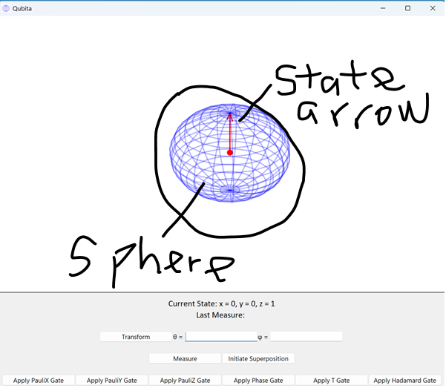

- 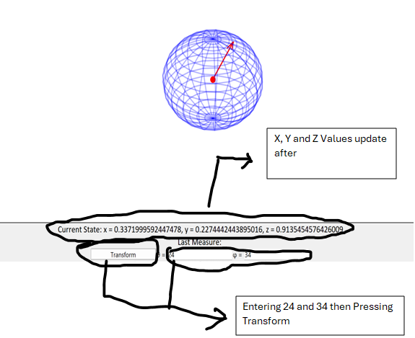

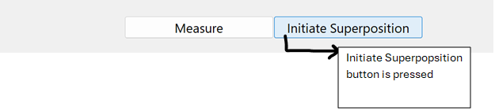
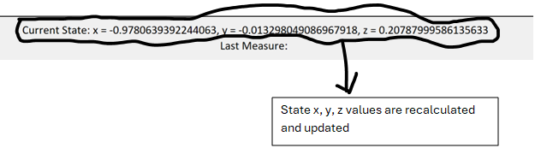
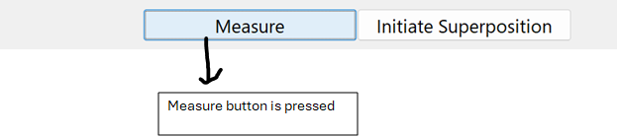
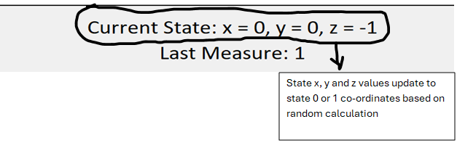
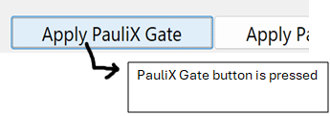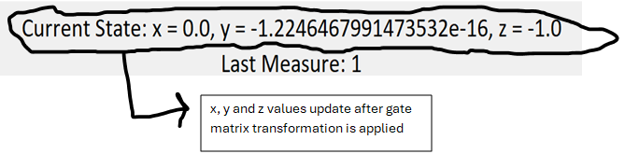
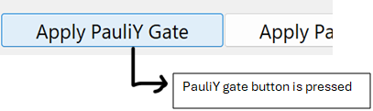
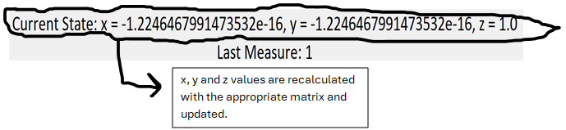
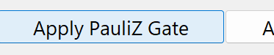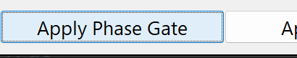
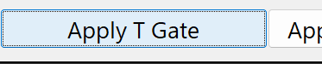
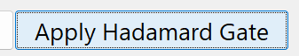
All other gate buttons are pressed and x, y, z values.
Test 2 is passed.

- 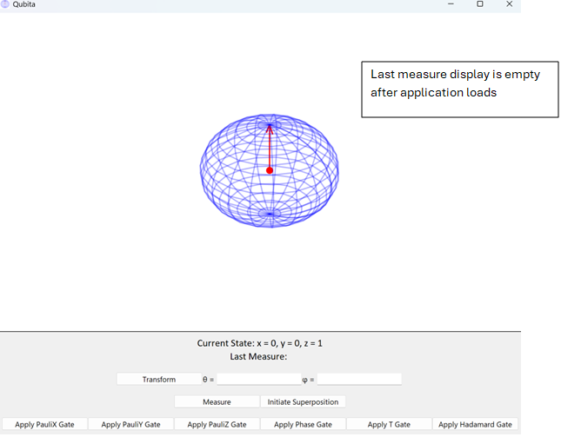
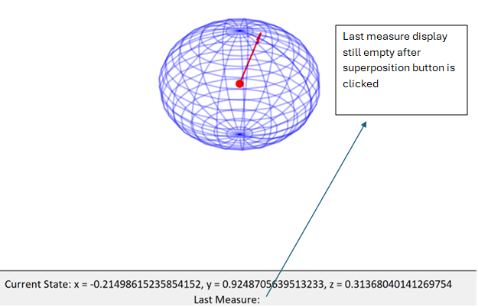
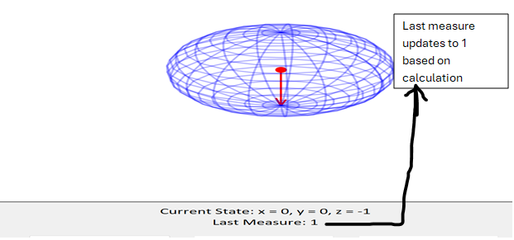
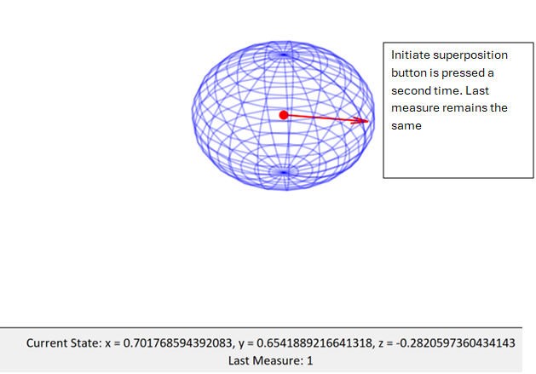
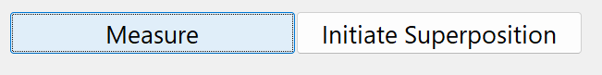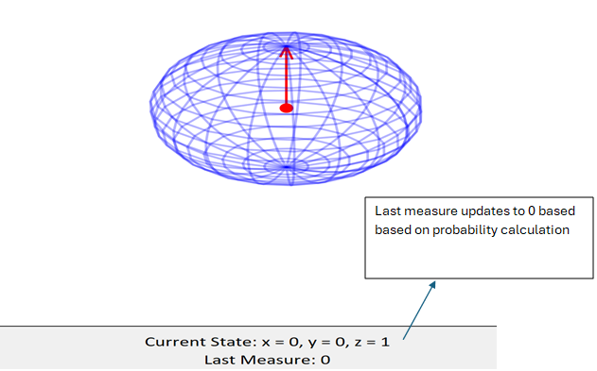
Test 3 is passed.

- 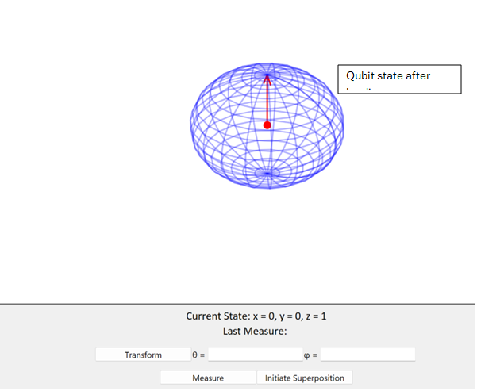
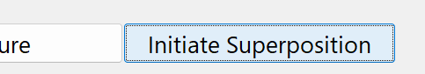
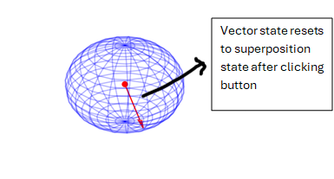Test 4 is passed.
- 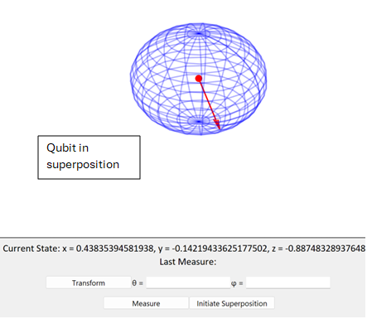
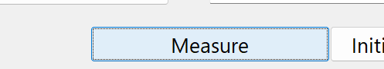

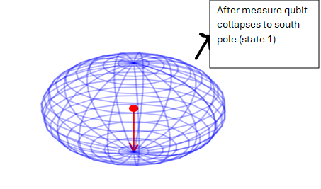Test 5 is passed

- 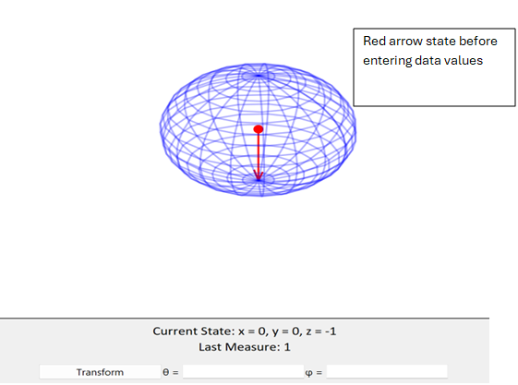

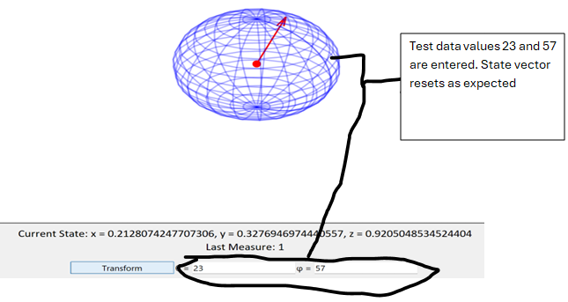
- 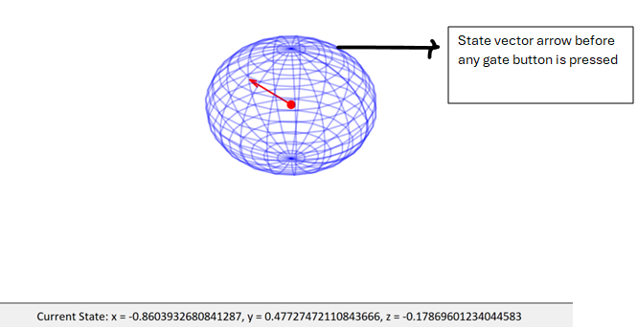
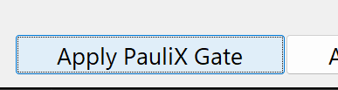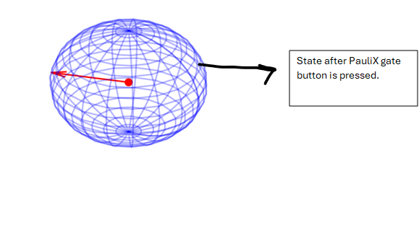
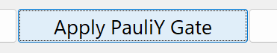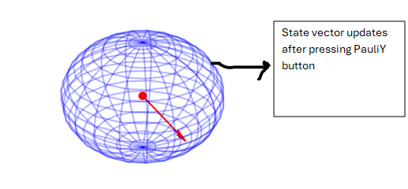
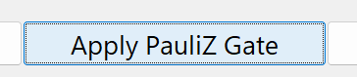
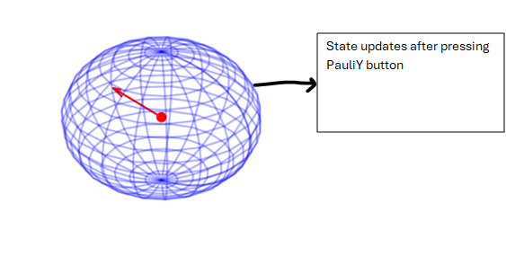

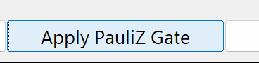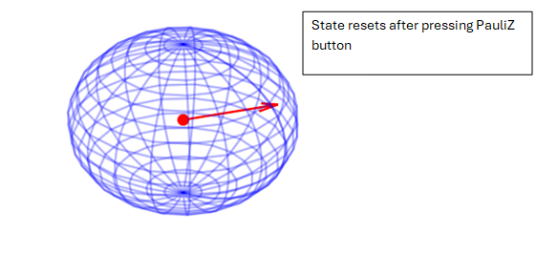
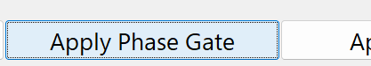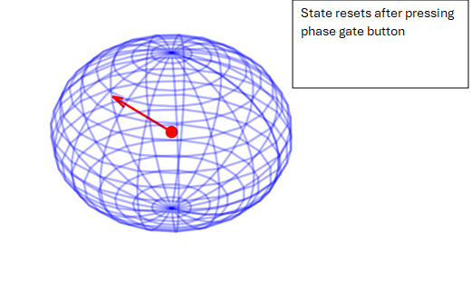

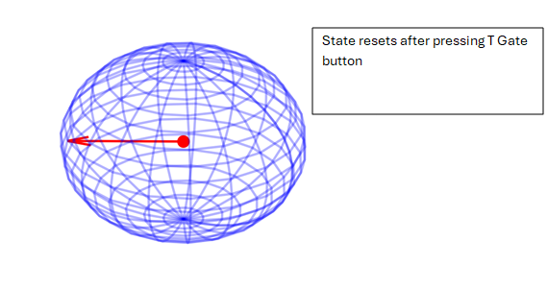
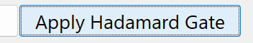
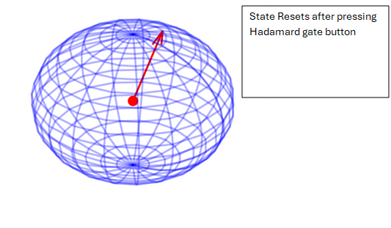

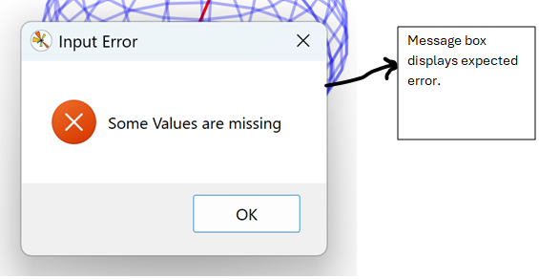

- Above is the display before trying to enter any of the test data.
After trying to enter @ and d into theta and phi entry – value is rejected, and Invalid Entry is displayed on screen.
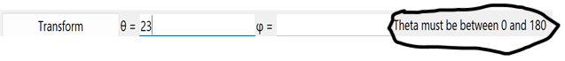While trying to enter 230 into theta entry, the entry box accepts 23 but as soon as I tried to enter the last 0, the message ’Theta must be between 0 and 18’ was displayed and value was rejected.
Same thing happened when I tried to enter 562 into phi entry, however, display is reconfigured to ’Phi must be between 0 and 360’.

- 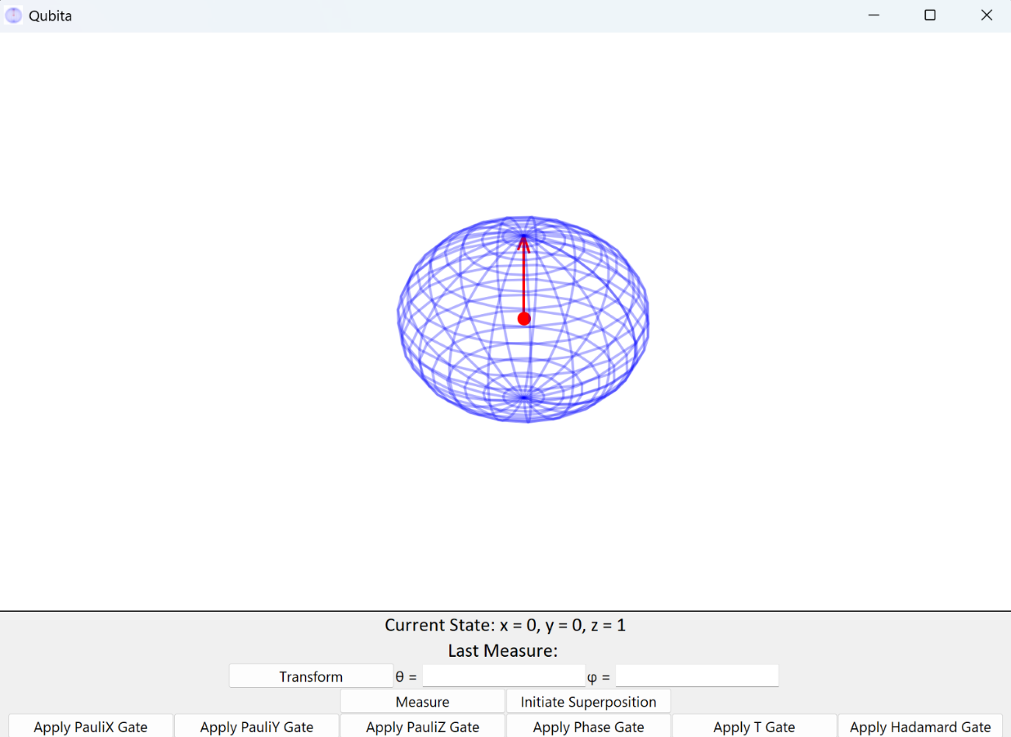The above is the application after loading.
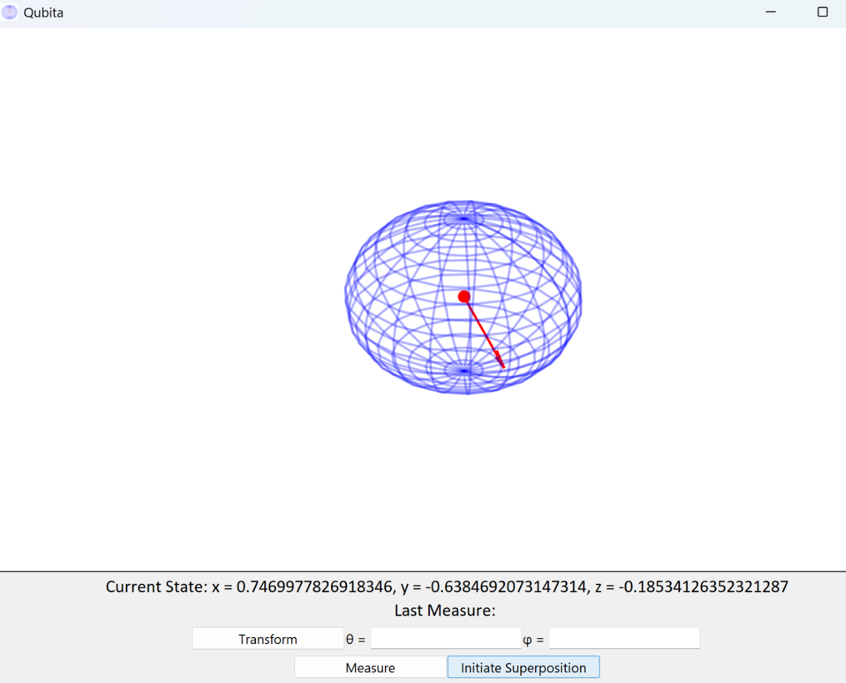
After clicking “Initiate Superposition” button, the state vector arrow resets as expected.
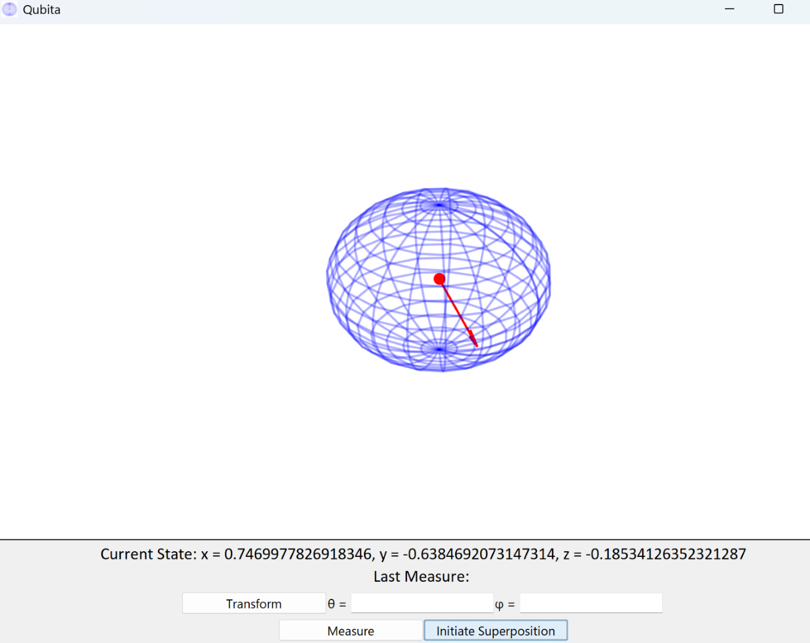After clicking “Initiate Superposition” button the second time, the state vector arrow remains the same as expected. However, it does not display error message box meaning test cannot be marked as completely passed.
Solution
def RunSuperpostion():
# Check if there is an error in running superposition and display
if type(Qubit.InitSuperposition()) == str:
error = Qubit.InitSuperposition()
messagebox.showerror('Superpostion Error', error)
return
else:
# if no errors run the method
Qubit.InitSuperposition()
# Update current state display
currentState = f"Current State: x = {Qubit.vectorState[0]}, y = {Qubit.vectorState[1]}, z = {Qubit.vectorState[2]}"
currentStateLabel.config(text=currentState)

The if statement in the code above is the code that runs the process of checking displaying the error message.
I first ensured that the Superposition procedure in the SuperPosition module returns the error message with the following code.
test = SuperPosition(0.456, 0.345, 0.789)
print(type(test))

By passing values that are x, y, z values that are non-basis state co-ordinates i.e. [0, 0, 1] and [0, 0, -1] it is expected that the type of the variable test will be str because the error message is a string.
Expected result is displayed after running.
def InitSuperposition(self):
# check if it returned error message i.e. Already in Superpostion, to ensure string returned is not passed to vector state
if type(SuperPosition.SuperPosition(self.vectorState[0],
self.vectorState[1],
self.vectorState[2])) == str:
# return the message to be used by error message box later
return SuperPosition.SuperPosition(
self.vectorState[0],
self.vectorState[1],
self.vectorState[2])
The above code is contained in InitSuperposition method in the StateVector class and checks if the Superposition module returns an error message and returns the message is it does.
I used this same logic the InitSuperposition in the Qubita class to ensure it returns the error message if the qubit object is in a superposition.
if type(StateVector.InitSuperposition(self)) == str:
# return the message to be used by error message box later
return StateVector.InitSuperposition(self)
I readapted it to use the StateVector InitSuperposition method as they are the inherited class and morphed method.
The following lines of code below were used to test that it works:
qubit = Qubita(1, 0.2, 0.4, 1)
print(type(qubit.InitSuperposition()))
In this code, I created a qubit object and initialized it in a superposition. Then, I tried to run the InitSuperposition method and because the qubit is in a superposition, it should return a string. Before the updated logic, this was the result:
After the updated logic:
The class now returns the message as a string if the qubit object is in a superposition.
After the updates I reran the application and tried the test again:
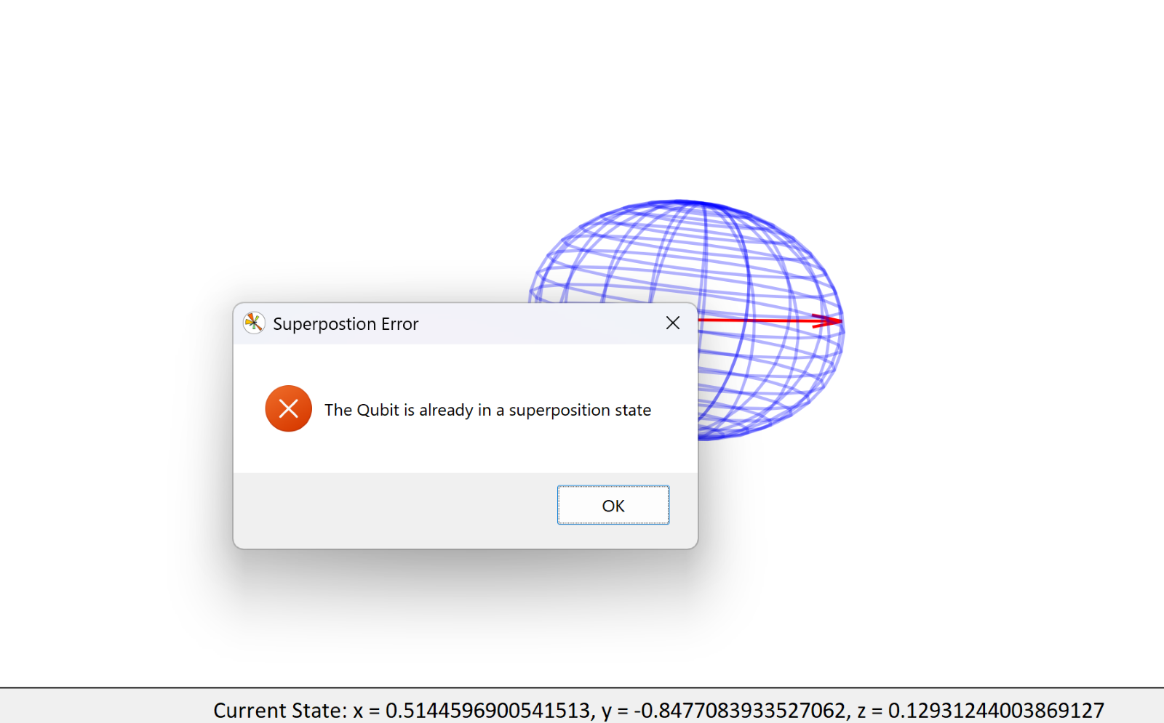The message box now displays the expected error if the qubit is in a superposition state i.e. neither south nor north pole of the sphere. Test 10 can be marked as passed.
- 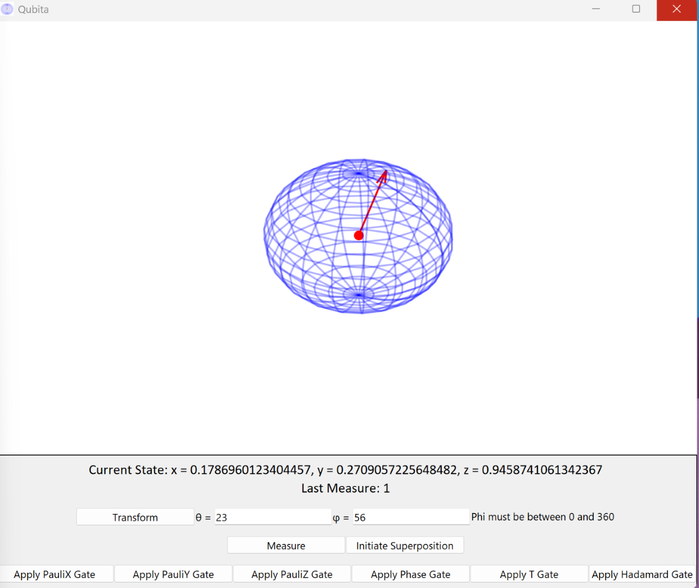Application closes as expected.

MODULE TEST
In this stage I will test some primary procedures of the supporting modules to ensure that the logic is correct.
- SuperPosition– SuperPosition function for objective 2d
- StateVector class – RotateVector method for objective 3a
- StateTransform module – TransformState function for objective 4c
- StateVector class – RotateVector method for objective 4e
- Gates – all gate functions for objective 5a
I will use a few lines of code to test that the logic of all the modules is accurate.

- This is to ensure that the randomly generated theta value in the SuperPosition module is appropriately passed (objective 2d) for measurement later. This is the function to be tested:
def SuperPosition(stateX, stateY, stateZ):
theta = GenerateRandomAngleTheta()
phi = GenerateRandomAnglePhi()
state = [stateX, stateY, stateZ]
basisState = CheckBasisState(state)
if basisState:
newState = StateTransform.TransformState(theta, phi)
return newState, theta
else:
return ErrorMessage

I added a line to display the theta value after the line theta = GenerateRandomAngleTheta() to know the random angle generated. Then I some lines after the scope of the function that stores its return value in a variable test and prints it.
def SuperPosition(stateX, stateY, stateZ):
theta = GenerateRandomAngleTheta()
print("Randomly generated angle in function scope", theta)
phi = GenerateRandomAnglePhi()
state = [stateX, stateY, stateZ]
basisState = CheckBasisState(state)
if basisState:
newState = StateTransform.TransformState(theta, phi)
return newState, theta
else:
return ErrorMessage

test = SuperPosition(0, 0, 1)
print(test)

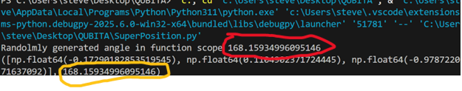The number highlighted in red is the randomly generated angle while the number in orange is the returned angle. As these values match, test 1 can be marked passed and objective 2d complete.

- This test is to ensure that the appropriate theta value of the current state is passed to the measure method (objective 3a). For this test I will use the following lines:
test = StateVector(0, 0, 1)
test.RotateVector(130, 23)
print(test.theta)
The first line instantiates a StateVector object test. In the next line, I run the method RotateVector() to calculate new x, y and z values for the object with theta = 130 and phi = 23. Then I check that the theta attribute of the object updates to 130 as this attribute is passed to the Measure function from Measure module in the Measure method:
# Measuring function from measure module, return collapse state and set vector State to it
def Measure(self):
# pass the theta attribute as argument
collaspeState = Measure.Measure(self.theta)

The print function should display 130 in the debug terminal:
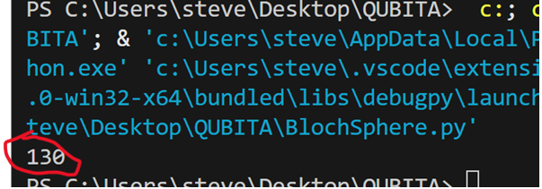
Print function displays expected outcome. Test can be marked as passed and objective 3a complete.

- This test is to ensure that the calculated x, y and z values based on theta and phi are accurate (Objective 4c)
def TransformState(theta, phi):
# convert to radians
theta = np.radians(theta)
phi = np.radians(phi)
# create empty list for new state values and calculate x, y and z
new_state = []
newX = np.sin(theta) * np.cos(phi)
newY = np.sin(theta) * np.sin(phi)
newZ = np.cos(theta)
# pass new value and return
new_state = [newX, newY, newZ]

return new_state

After searching multiple internet resources, I can confirm that these are the correct formulas for x, y and z values of a point on a Bloch sphere. Objective 4c can be marked as complete. (Glemming, 2005).

- This test is done to ensure that the appropriate theta value is passed for measure after a state transformation occurs (objective 4e). The same method in test 2 can be used for this test (refer to test 2):
test = StateVector(0, 0, 1)
test.RotateVector(130, 23)
print(test.theta)
This test has already been passed in previous demonstrations hence objective 4e can be marked complete.

- This test is done to ensure that all the gates' functions return their expected results. The code below was used:
# Gates Test

# function to get var name
def namestr(obj, namespace):
return [name for name in namespace if namespace[name] is obj]

# Gates test variables
PauliXTest = PauliX(0, 0, 1)
PauliYTest = PauliY(0, 0, 1)
PauliZTest = PauliZ(-1, 0, 0)
PhaseGateTest = PhaseGate(-1, 0, 0)
TGateTest = TGate(-1, 0, 0)
HadamardGateTest = HadamardGate(0, 0, 1)

# All tests
AllTests = [PauliXTest,
PauliYTest,
PauliZTest,
PhaseGateTest,
TGateTest,
HadamardGateTest]

# Loop through all tests, display test name and display result
for i in range(0, len(AllTests)):
print(namestr(AllTests[i], globals()), " = ", AllTests[i])

I created a series of variables that store the gates results. PauliX, PauliY and HadarmardGate take x=0, y=0 and z=1 (state 0). PauliZ Phase and T gates were passed the values [-1, 0, 0] as they all have no effect on state 0 and I would prefer to be able to differentiate between them.

Calculated Expected Results (small values to 3d.p)
PauliXTest = [0, -1.225 x 10⁻¹⁶, -1]
PauliYTest = [1.225 x 10⁻¹⁶, 0, -1]
PauliZTest = [1, -1225 x 10⁻¹⁶, 0]
PhaseGateTest = [-6.123 x 10⁻¹⁷ , -1, 0]
TGateTest = [-0.707, -0.707, 0]
HadamardGateTest = [-1, -1.225 x 10⁻¹⁶, -6.123 x 10⁻¹⁷]

End Result
After running the code, the terminal displayed the following result.
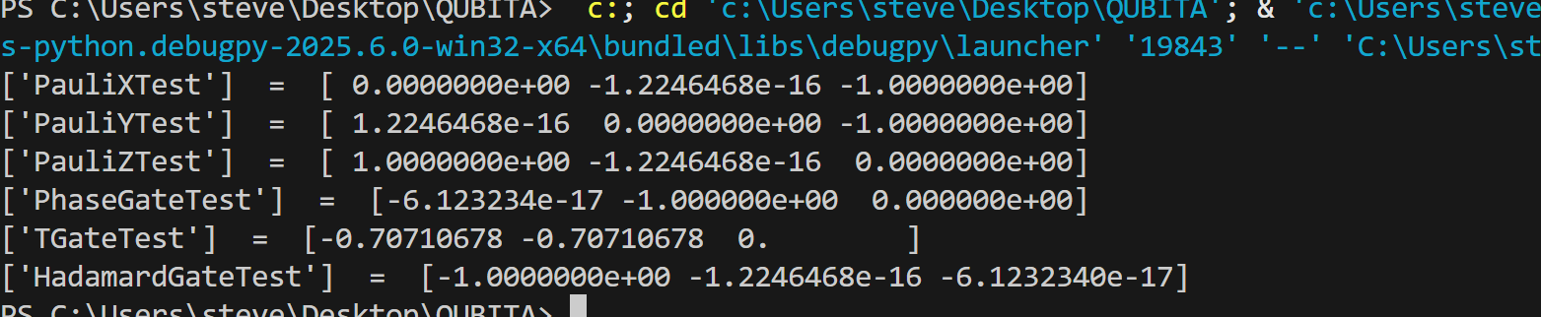
N.B. - for integer values n en in NumPy represents 10^{n}. E.g. e-17 represents 10⁻¹⁷.
All values match the expected result hence test can be marked as passed and objective 5a complete.

Success of the UI layout is discussed in the evaluation phase.

EVALUATION
The solution has largely been a success. I have created a robust interface that sufficiently simulates a single bit quantum system for a beginner to follow with all errors working.
The objectives of the software have been evolving throughout the project due to its complex nature. However, the solution generally followed the framework developed in the analysis and design stage.
Below is a tabular evaluation of objectives 1 – 6.
Objective/Description | Test | User Feedback
1- Qubit Initialization. | The test Involved loading the program and ensuring that it the qubit is plotted and displayed on the screen i.e. sphere and state arrow. This was successful on the first try hence there was no need for redesign. | The user was satisfied with the plot. They stated that they like the mesh structure and the contrasting color of the sphere and the simulation system to user interface ratio.
2- Putting the qubit in superposition. | A series of tests were conducted to ensure that this functionality is working and robust enough. All except one test passed. The failed test involved pressing the superposition button twice to Ensure that an error is displayed if a similar case occurs. Although the qubit did not respond the second time, the error was not displayed as expected. The issue was with the function returning the error string and it was fixed after a quick redesign. | User was satisfied with this functionality and appreciated that an error message is returned if the system is already in a superposition.
3- Measuring and collapsing the qubit. | The qubit collapsed to one of the basis states 1 or 0 when the measure button was pressed based on a random calculation done in the Measure module. The display “Last Measure” also updated to the accordingly.  A key parameter in the calculation is the theta value of the current state. A series of module tests were done to ensure that the appropriate this is stored and updated in the “theta” attribute of the qubit. | The user was satisfied with this functionality and had no comments.
4- Transforming to superposition state based on user theta and phi inputs. | This is the most error prone functionality as it depends on user input to transform to a new state. My prevention routine involves rejecting values outside the range of theta and phi and invalid entries with the reason for the rejection displayed on the UI.  During the test phase, I tried some values that were within the criteria defined previously and the UI responded as expected i.e. rejecting these values and displaying the reason. I also tried valid entries, and the qubit system transformed to the expected state. | The user was largely satisfied with the solution but noted that it felt too abstract, lacking explanation behind the process. I clarified that the original design was intended as a visual aid rather than a primary resource, ensuring my tone remained respectful. I also reassured the user that future updates will provide more concrete explanations.
5- Gates | All gate buttons were utilized during the test and worked appropriately. A module test was also conducted to ensure that the right matrices are being applied. | The user was impressed with the integration of this feature as they suggested it during the post design interview.
6- Window close | The application closed as expected. | N/A

FEEDBACK (Google Forms)
In the analysis stage I outlined my plan to collect feedback via a google form to evaluate the success of the UI and accuracy of the simulation. Below are the questions in the form:
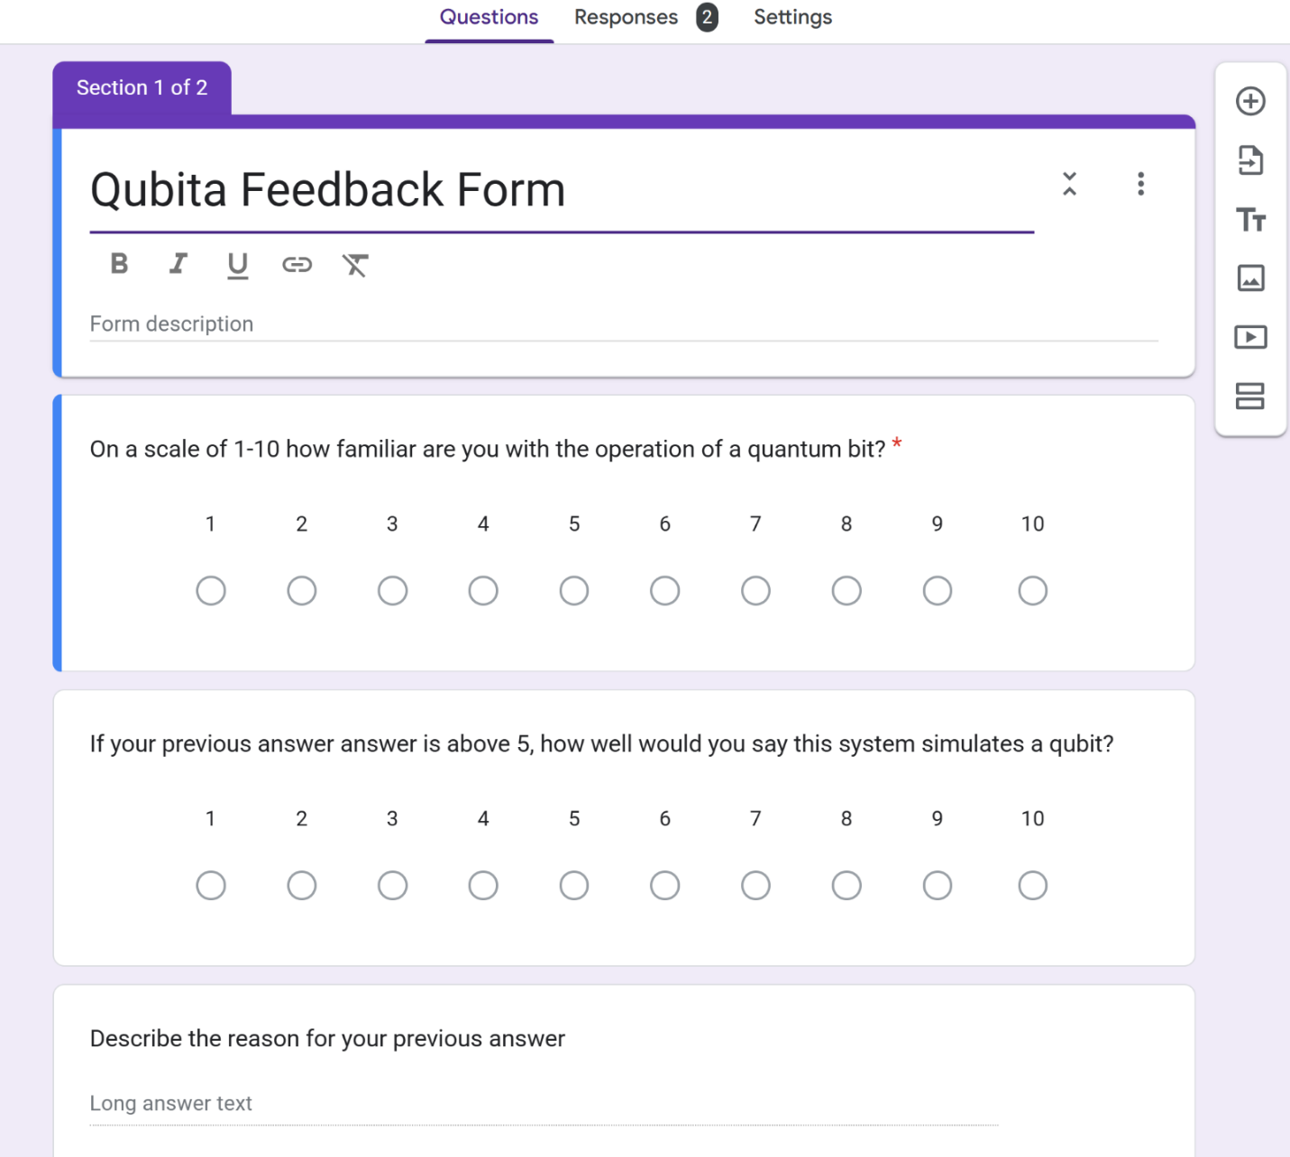
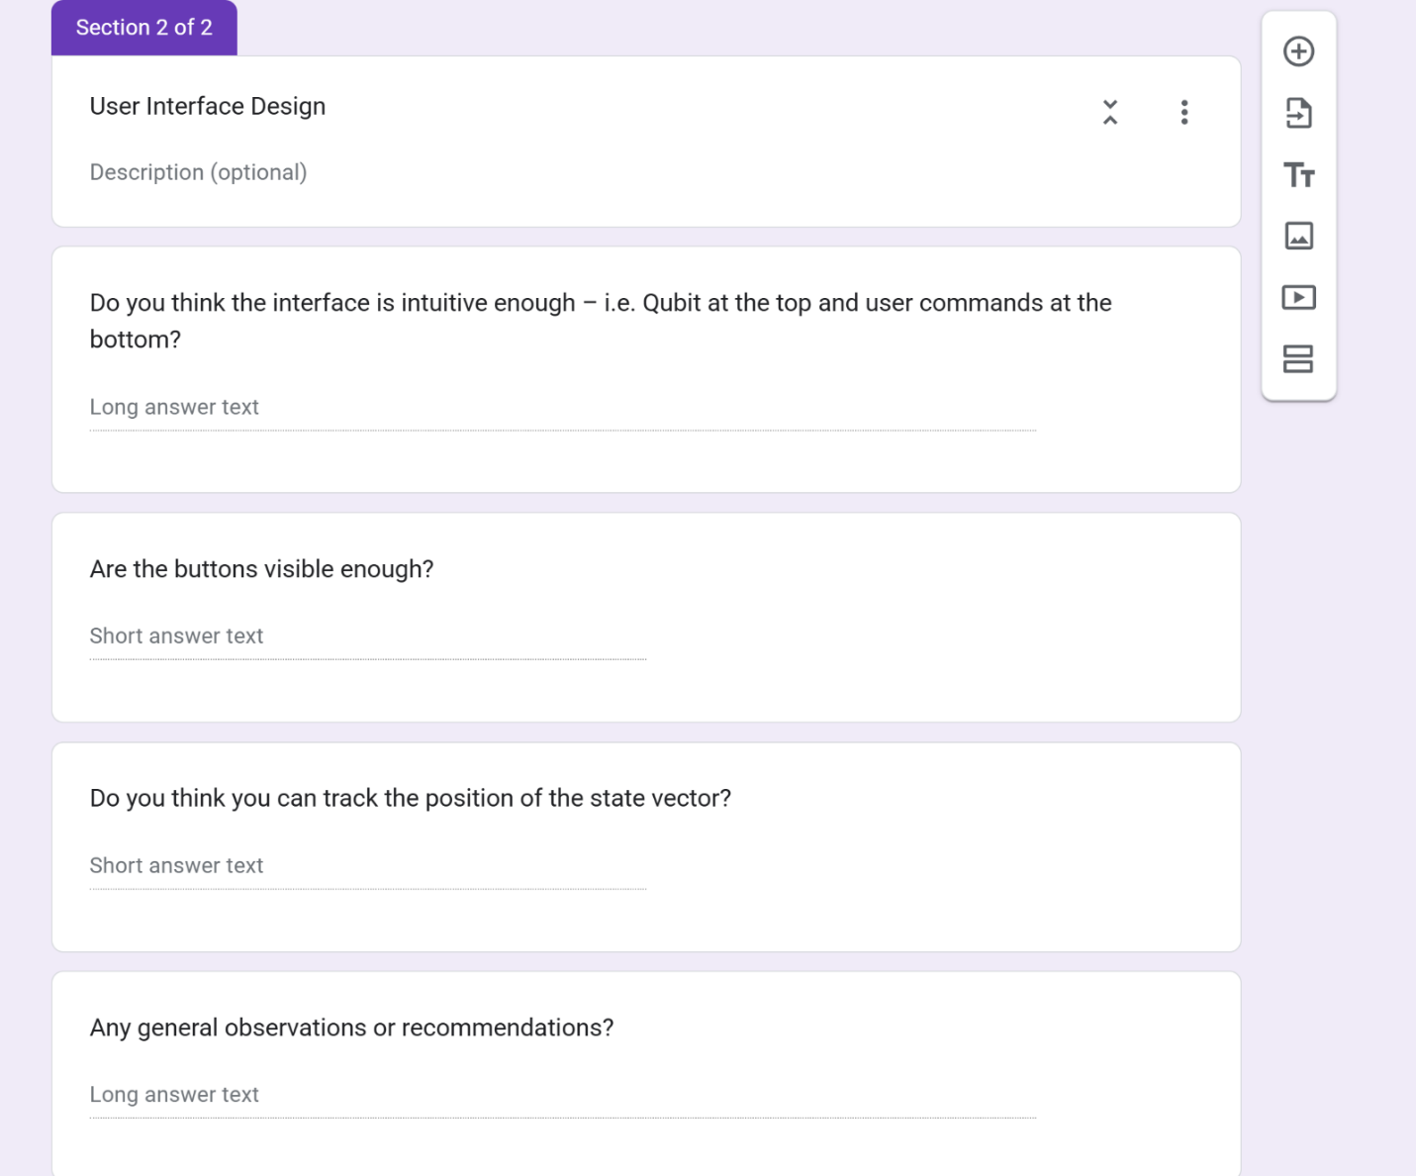
I got 2 responses, one from end user Mr. W. C and a quantum computing specialist I connected with on the internet who preferred to be kept anonymous.

MR. W. C. Response
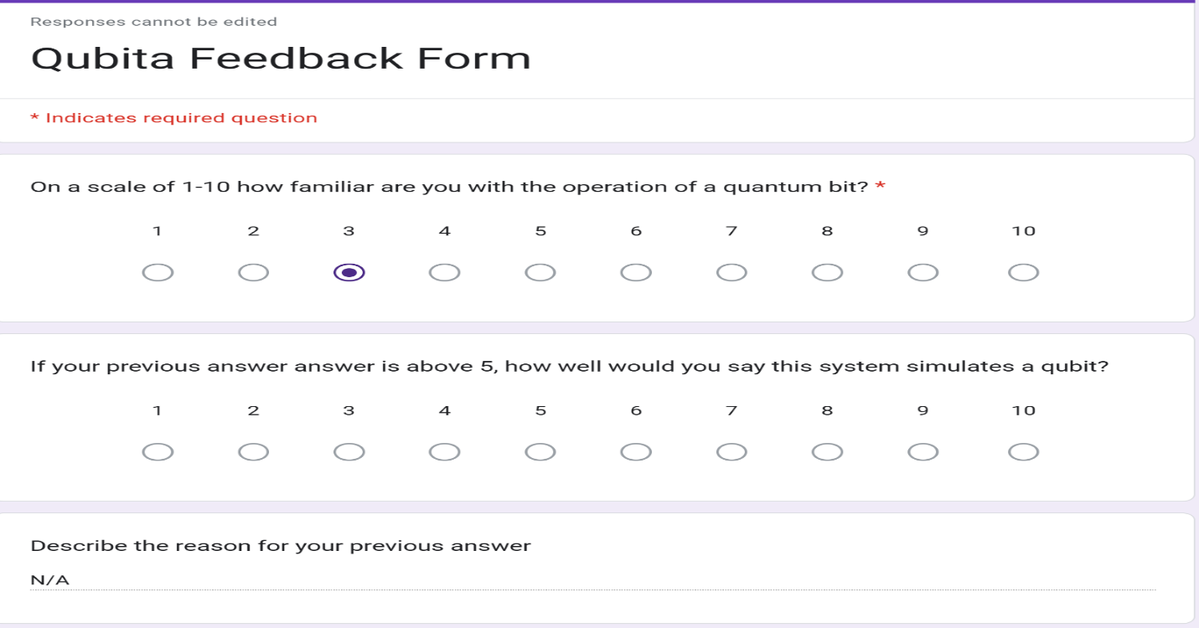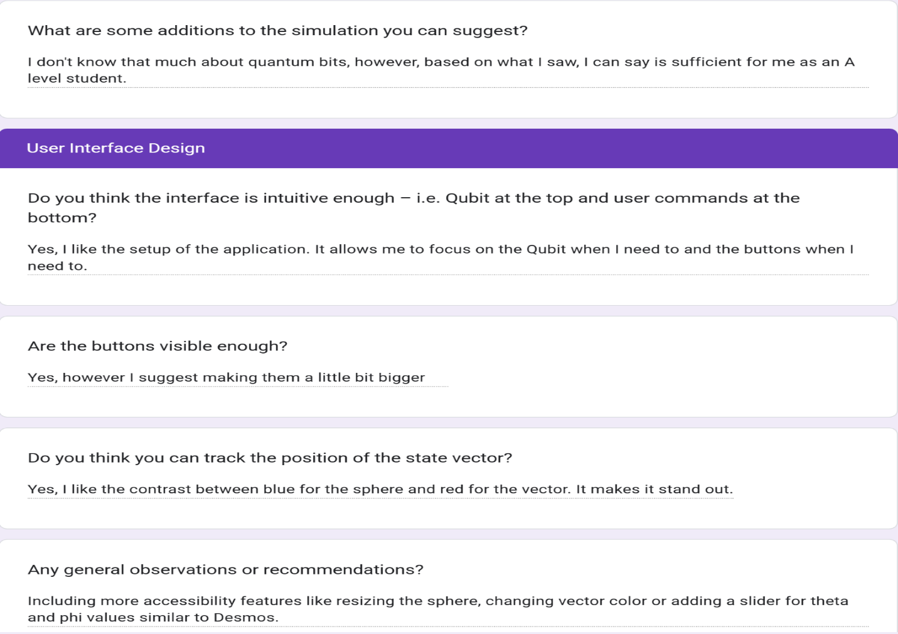
As end user Mr. W. C. is not a specialist in quantum computing, he had little to say about the accuracy of the simulation. With the little knowledge he had, however, he stated that it is sufficient for an A level student.

Specialist Response
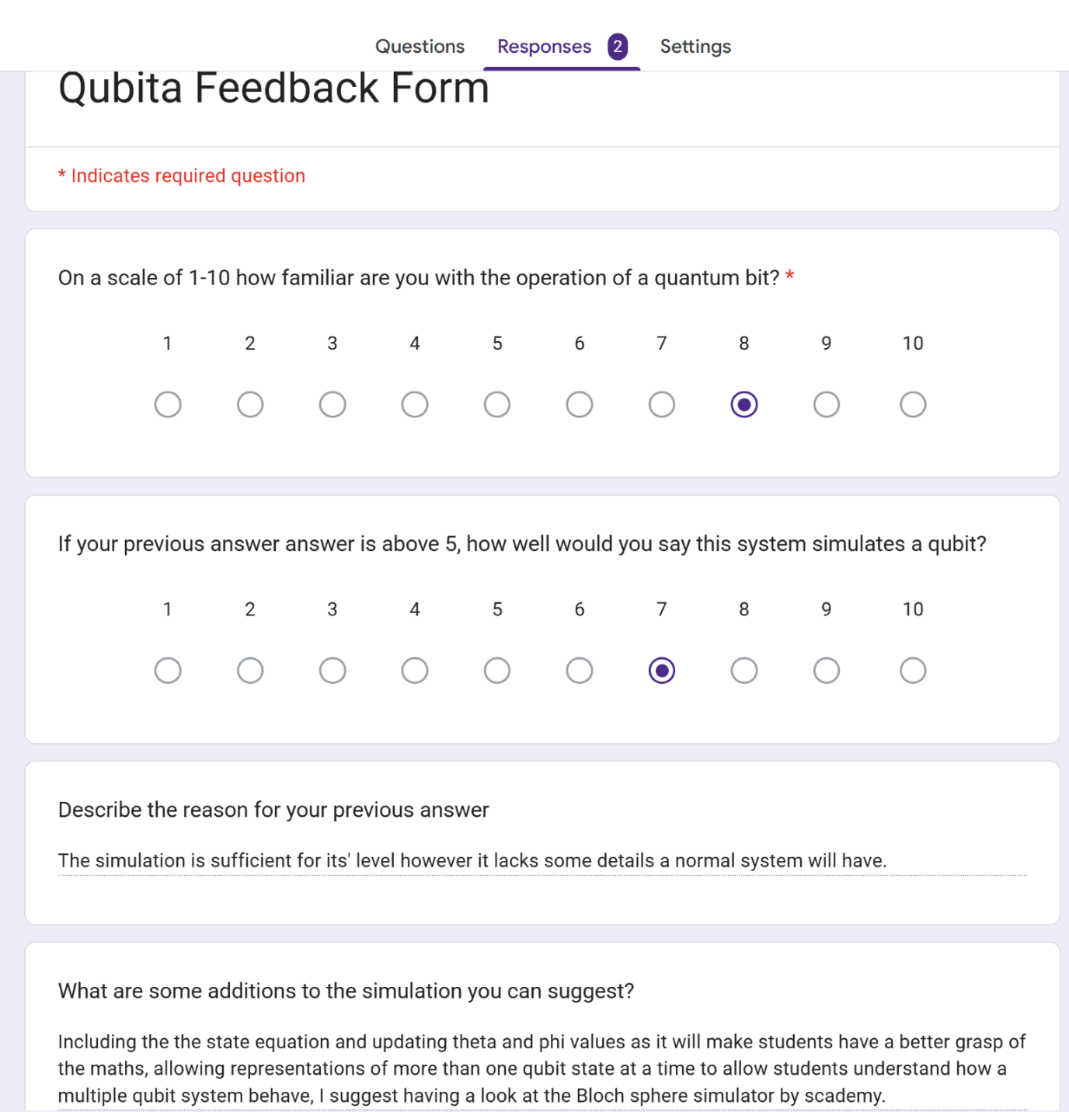
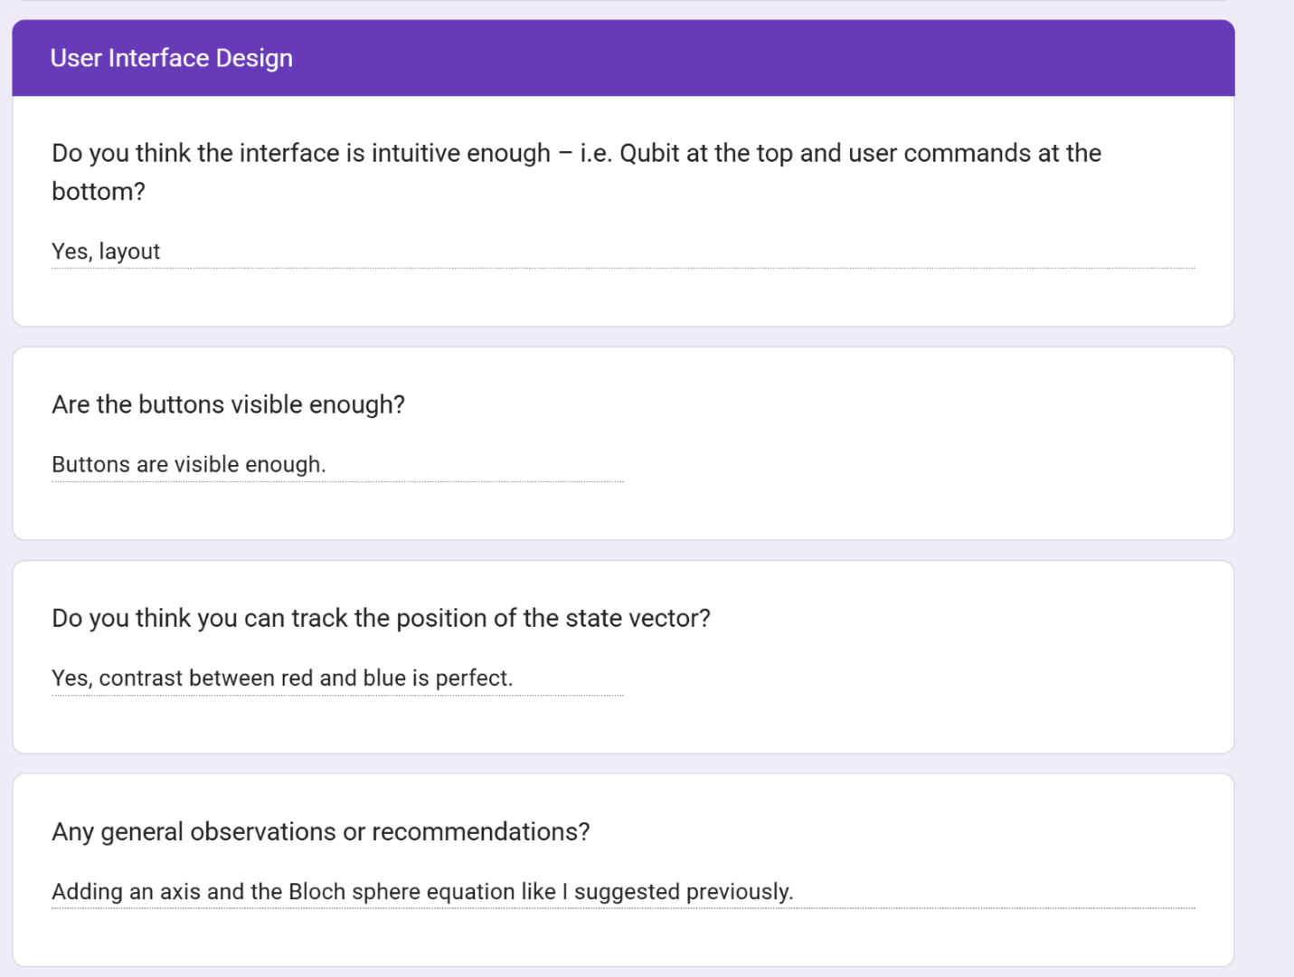
The specialist was largely impressed by the system considering the level of students it was designed for i.e. beginner level. They did indicate that it lacked some features a more robust system will have, however, this is to be expected as the intention was to design the simplest but representative simulation for beginners. More importantly, they pointed me to another simulation Bloch Sphere Simulator by S Academy¹ which is similar to my project but has more functionality. They recommended that I consider modelling some of its features and including them in future updates.

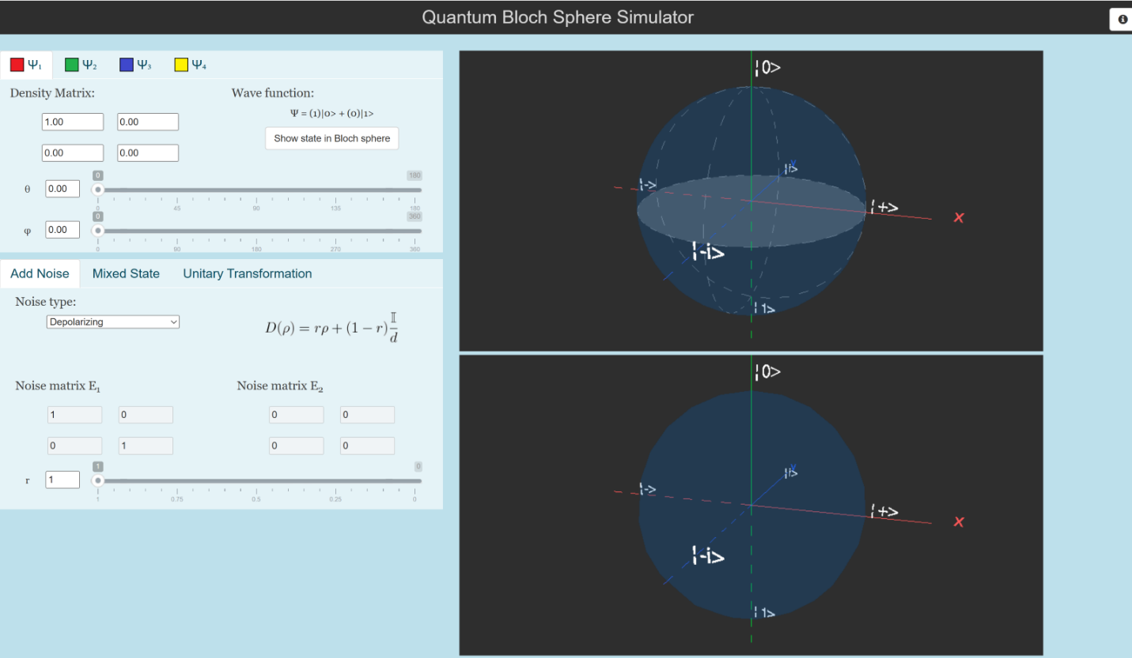¹Screenshot of Bloch sphere simulator by s academy

UI Reflections
End user Mr. W. C. appreciated most aspects of the UI however, they recommended adding more accessibility features particularly, resizing the sphere, changing the vector color and adding a slider for entries. He also called attention to the button size indicating that they are smaller than they expected. This will be fixed in the stable/final release.
The specialist suggested that I include an axis, however, my decision to exclude it was due to end User Mr. W. C’s request during the post design interview. A good suggestion is to include the vector state equation, updating theta and phi based on the current state. This will allow users to easily understand how polar equations are used to model qubit states.

Areas of Improvement
The Simulation
As stated by the specialist, although sufficient for the level of students it was designed for, the system lacks some features that a normal quantum bit simulator will have. A big update I am looking forward to in the future is adding the state equation to allow users see how the current state affects its parameters in real time. Furthermore, in the application recommended, there is an option to represent up to four states, perhaps to simulate a multi-qubit system.
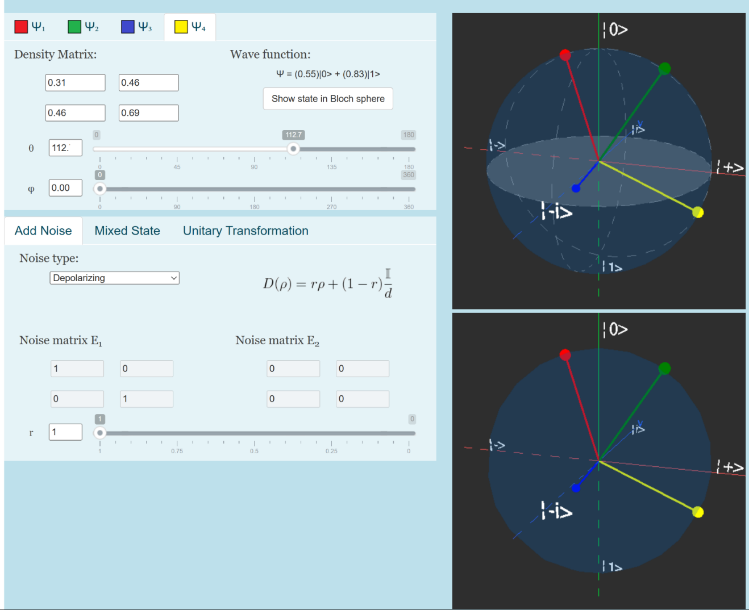
I believe that simulating a multi-qubit system with more gates will elevate the application and will be the main goal for Qubita 2.0.

The UI
Responses suggested that the UI was successful, however, in the future I intend to:
- Increase the button size
- Allow users to customize the qubit size and colors
- Include a menu option that allows users to save qubit states and access a help menu
- Include sliders for theta and phi entry

Feedback
The feedback collected was weak as I was only able to get two responses. In the future, I intend to make a public feedback form for users to fill in with more specific optimization, simulation and UI layout questions allowing me to do more quantitative analysis on the application’s success and failures.

REFERENCES
(2023) Three-dimensional plotting in python using Matplotlib, GeeksforGeeks. Available at: https://www.geeksforgeeks.org/three-dimensional-plotting-in-python-using-matplotlib/ (Accessed: 16 January 2025).

(No date a) Python - plotting a 3D cube, a sphere and a vector - stack overflow. Available at: https://stackoverflow.com/questions/11140163/plotting-a-3d-cube-a-sphere-and-a-vector (Accessed: 19 February 2025).

(No date b) Coordinate systems. Available at: https://sites.science.oregonstate.edu/math/home/programs/undergrad/CalculusQuestStudyGuides/vcalc/coord/coord.html#:~:text=The%20coordinates%20used%20in%20spherical,the%20origin%20and%20the%20point. (Accessed: 05 February 2025).

Codemy (no date) Python Gui’s with Tkinter, YouTube. Available at: https://www.youtube.com/playlist?list=PLCC34OHNcOtoC6GglhF3ncJ5rLwQrLGnV (Accessed: 02 August 2024).

GeeksforGeeks (2025) Numpy.zeros() in Python, GeeksforGeeks. Available at: https://www.geeksforgeeks.org/numpy-zeros-python/ (Accessed: 14 February 2025).
Glemming, I. (2005) Bloch-sphere.pdf, Bloch Sphere. Available at: http://web.cecs.pdx.edu/~mperkows/june2007/bloch-sphere.pdf (Accessed: 24 March 2025).

Ibm (2025) What is quantum computing?, IBM. Available at: https://www.ibm.com/think/topics/quantum-computing#:~:text=IBM%27s%20quantum%20computers%20are%20programmed,%2C%20optimization%2C%20and%20machine%20learning. (Accessed: 20 April 2024).

Libretexts (2023) 4.6: Rotation matrices in 3-Dimensions, Mathematics LibreTexts. Available at: https://math.libretexts.org/Bookshelves/Applied_Mathematics/Mathematics_for_Game_Developers_(Burzynski)/04%3A_Matrices/4.06%3A_Rotation_Matrices_in_3-Dimensions (Accessed: 14 November 2024).

NeuralLine (2023) MatplotLib Full Python Course, YouTube. Available at: https://www.youtube.com/watch?v=OZOOLe2imFo (Accessed: 17 December 2024).

Numpy user guide# (no date) NumPy user guide - NumPy v2.2 Manual. Available at: https://numpy.org/doc/stable/user/ (Accessed: 15 November 2024).

Pseudoeditor (no date) Pseudocode Editor Online. Available at: https://pseudoeditor.com/ (Accessed: 10 November 2024).

Quantum Bloch Sphere Simulator (no date) Bloch Sphere Simulator. Available at: https://quantum.scademy.com/ (Accessed: 23 April 2025).

The qubit game (no date) Google Quantum AI. Available at: https://quantumai.google/education/thequbitgame (Accessed: 13 August 2024).

Wong, T.G. (2022) Introduction to classical and quantum computing. Omaha, NE: Rooted Grove.

Woody, L.S. (2022) Essential Mathematics for Quantum Computing: A beginner’s guide to just the math you need without needless complexities. Birmingham: Packt Publishing, Limited.

Xq (2020) Understanding the theory and math behind qubits, Medium. Available at: https://medium.com/the-research-nest/understanding-the-theory-and-math-behind-qubits-2bf86a56441c (Accessed: 15 April 2024).
APPENDIX
QUBITA v1.0 DOCUMENTATION
In recent years quantum computing has become more feasible in the world of computing. With its boom, there has been a space that is yet to be filled in computer science education as it is portrayed as a field only for specialists with no mention of it in beginner computer science courses like A-Levels. Qubita aims to fill a portion of that space as it is the first of its kind, that is, a simulation to aid, not university students, but novice computer scientists particularly, particularly, A-level students being introduced to the world of quantum computing.

Prerequisites
Any windows system with at least 2gb of ram and 1 mb space free can run Qubita.
Qubita was developed with python, hence, to run it you must install python 3, preferably version 3.11 and above.
Visit python.org to download the latest version!

After installing python, there are some libraries you need to run the program smoothly:
- matplotlib
  - Open command prompt or terminal
  - Type the command pip install matplotlib
  - Ready to go!
- NumPy
  - Open command prompt or terminal
  - Type the command pip install numpy
  - Ready to go!

If all requirements are met, look for the batch file “run qubita command” and click it.
Your program is running!

How to Use Qubita
To enjoy qubita, accompany it with a quantum computing book. After running the program, the following screen should come up:
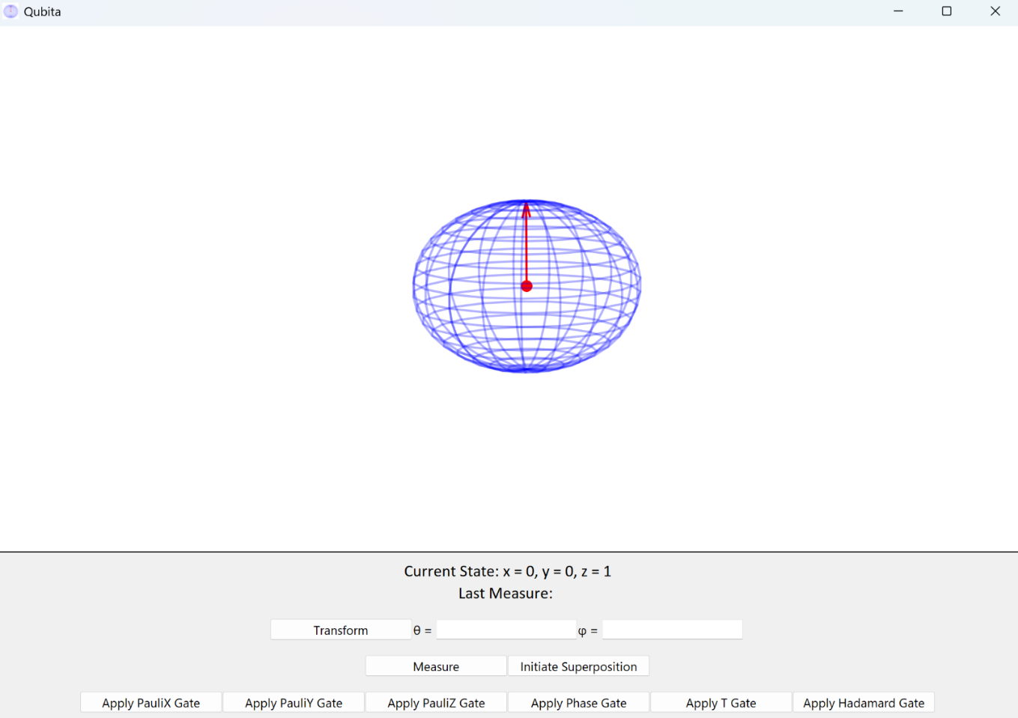

There are four main functions in the application:
- Transform
- Measure
- Superposition
- Gates (6 quantum gates)
To use the transform function, enter any number between 0 - 180 in the theta entry and 0 – 360 in the phi entry and press the button “Transform”.
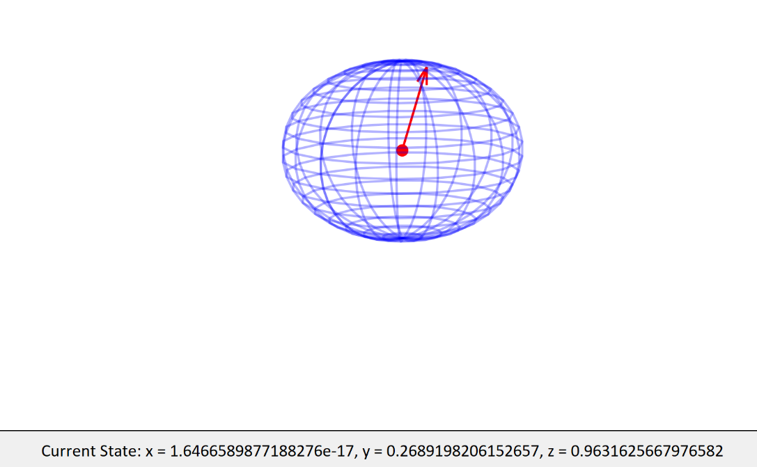
The qubit will update to the new state and the x, y and z will update to new values.
Note – Entry must be within the range and cannot be empty or else an error message will display.
To use the measure function, simply press the button.
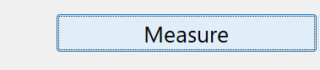
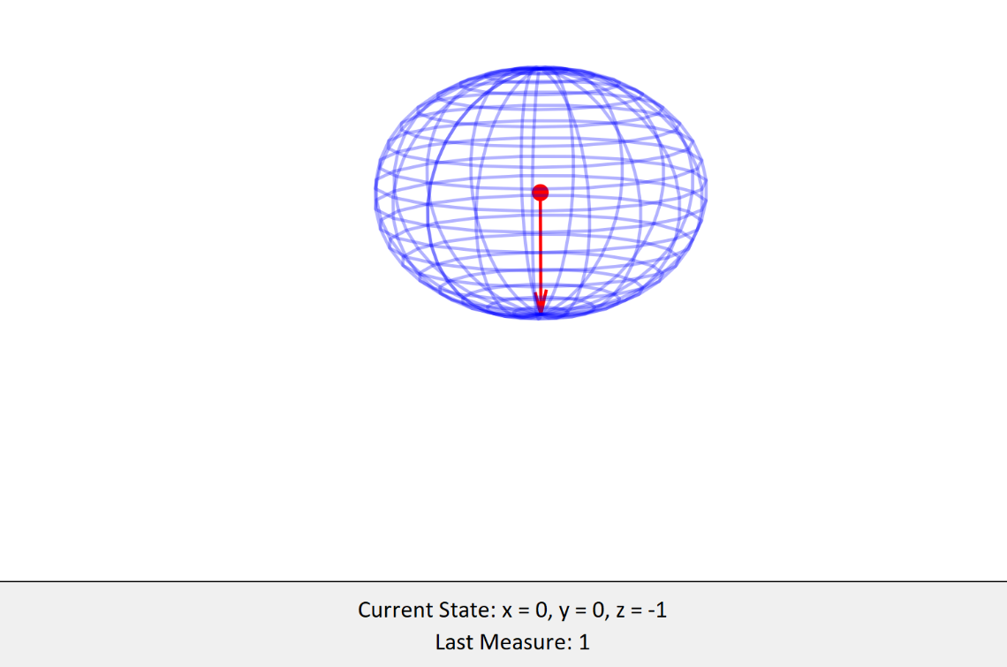
The red arrow should now be pointing at the north or south pole of the sphere, and the display “Last Measure” should now be 1 or 0.

To use the superposition function, make sure the Qubit is not in a superposition already, i.e. the red arrow is pointing due north or south. Then press the button “Initiate Superposition”.
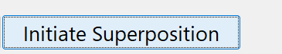
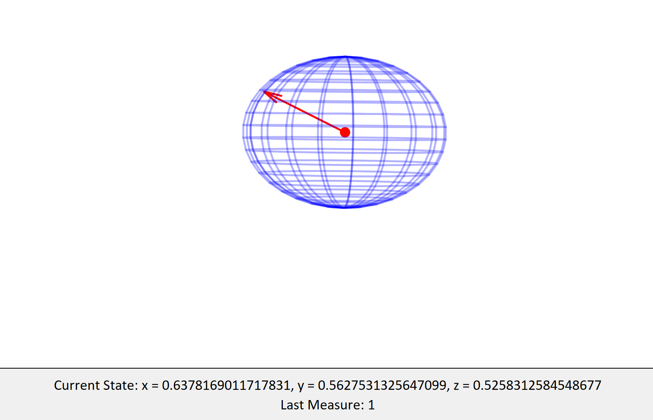
The arrow should now be pointing to a random direction that is not the north or south pole.
Note – if you try to use this feature and the arrow is not pointing north or south, an error message will display.

To use any of the gates, simply press their corresponding buttons and the arrow will reposition itself according to the state that the gate transforms them to. For example, if you want to Apply PauliX gate to the current qubit state:
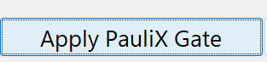
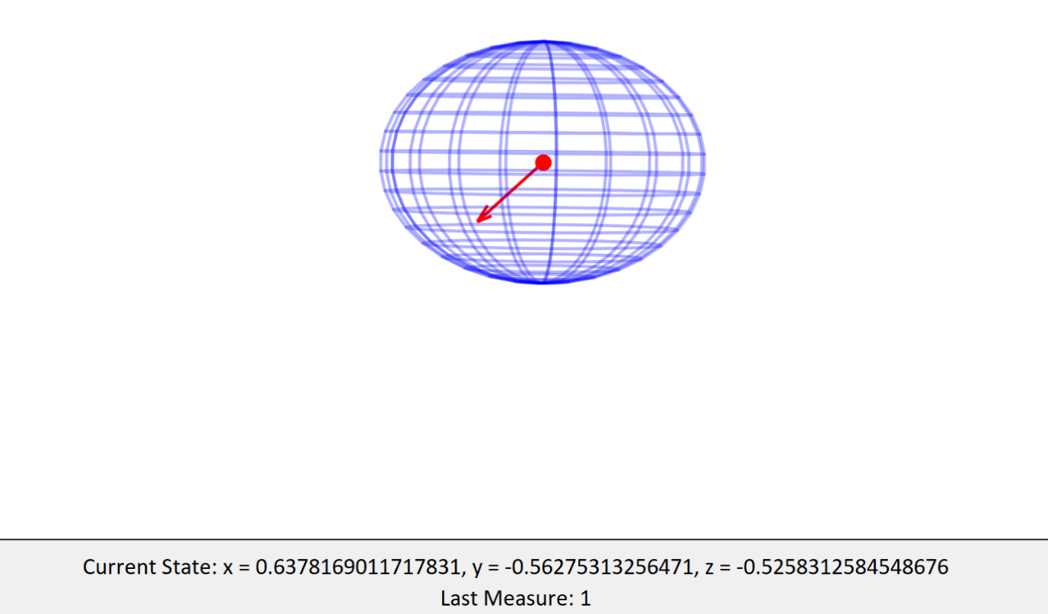

To learn more about qubits and quantum behavior, visit Qiskit or Microsoft Quantum.

A google forms document will soon be available to collect feedback as I am working on improving this application and there will be more features and educational content in the future. Goodluck on your quantum computing journey.

Developer(s)
Stephen Yohanna

